A Methodology for Validating the Thematic Quality of Decametric Spatial Resolution Leaf Area Index and FAPAR Products using In-Situ Fiducial Reference Measurements

October 29, 2026
Fernandes, Brown, Nickeson, Niro, Tang + all others in alphabetical order

Document Change Record
Iss. | Rev. | Date | Reason | Comments
0 | 0 | October 24, 2025 | Initial draft | Draft outline for CEOS review
0 | 1 | November 13, 2025 | CEOS draft | Draft outline for external review
0 | 2 | June 6, 2026 | Major revision after initial external review. | Scope reduced and methods simplified.
0 | 3 | June 11, 2026 | Improve flow of text up in intro and theory. Added Stage 4 results and removed GPR approach from stage 4. | Finish initial figures for CEOS reviewer to comment.
0 | 4 | October 19, 2026 | Reduce figures and incorporate feedback. | I have still to respond to specific feedback from last set of LPV comments but I have significantly simplified results to make it easier to follow.
0 | 5 | October 29, 2026 | Completed references, glossary and table of symbols. Drafted conclusion. | I am still missing some global results near equator (there is some persisten GEE issue). This will take a few days to fill in but will not change results.

Abstract

Leaf Area Index (LAI) and the Fraction of Absorbed Photosynthetically Active Radiation (FAPAR) are biophysical indicators that, respectively, quantify terrestrial vegetation density and potential gross primary productivity. LAI and FAPAR products at spatial resolution $≤$250m and temporal resolution $≤$10d are required by the United National Global Climate Observing System (GCOS). These requirements can now be satisfied using data acquired by constellations of decametric resolution satellite images. However, GCOS and other users also have thematic quality requirements related to uncertainty and stability. There is currently no globally applicable method for assessing conformity to these requirements. This study presents a methodology for validating conformity of current decametric resolution LAI and FAPAR products with thematic quality requirements for uncertainty and stability in a manner compliant with Committee of Earth Observing Systems (CEOS) good practices.

Joint Council of Guidelines for Metrology (JGCM) protocols, required by the CEOS endorsed Quality Assurance Framework for Earth Observation panel, are used to specify conformity tests for GCOS requirements for relative standard uncertainty, defined as the standard deviation of bias corrected residuals divided by the product measurement, and temporal stability, defined as %change in bias per decade. These tests correspond to comparing the confidence interval of quality statistics estimates using residuals observed for matchups of coincident product measurements and in-situ fiducial reference measurements with GCOS specified tolerance intervals. Confidence intervals are estimated for each matchup by weighting robust estimates of residuals at all matchups with a relative inclusion probability that is a function of climate, land cover, and biophysical characteristics of each in-situ elementary sampling unit.

The methodology is applied to products derived by applying the Simplified Level 2 Prototype Processor algorithm to a global subsample of 30m resolution Harmonized Landsat and Sentinel 2 (HLS) data using either data having Landsat spectral bands or alternatively, only Sentinel 2 spectral bands. The GroundedEO fiducial reference measurements database was used for bias correction and to quantify uncertainty and stability. SL2P using Landsat bands resulted in a LAI uncertainty of <1 and FAPR uncertainty of <0.1 and a stability <0.02yr-1, all for a 67.5%ile interval. SL2P estimates using Sentinel 2 bands resulted in reduced uncertainty of up to 50% but similar stability, when compared to SL2P estimates using Landsat bands. For the majority of LAI and FAPAR comparisons, the probability of conformity of SL2P estimates from Landsat bands with GCOS threshold requirements is below 0.2 for uncertainty and above 0.5 for stability. The low conformity was due to both retrieval errors and wide confidence intervals for estimates of uncertainty. Global estimates of uncertainty and stability indicates similar patterns as those observed for reference sites but with low representativeness over Africa and central Asia.

Introduction
Leaf area index (LAI) and the fraction of absorbed photosynthetically active radiation (FAPAR) (hereafter collectively LAI/FAPAR) measure terrestrial vegetation density and potential gross primary productivity, respectively (Watson, 1947; Monteith 1972; WMO, 2022) (bold terms are defined in Appendix 1). LAI/FAPAR are essential agriculture, biodiversity and climate variables required for monitoring vegetation and modelling land surface processes (Navarro et al., 2017; GEOGLAM 2022; United Nations, 2022; FAO, 2025; WMO, 2025).

LAI/FAPAR thematic data products are routinely generated at synoptic and global extents using fundamental data records (FDRs) from satellite optical imagers, synthetic aperture radar (SAR) imagers and light detection and ranging (LiDAR) instruments (Fernandes et al., 2014; Campos-Taberner et al., 2017; CEOS, 2018; Fang et al., 2019a; Dubayah et al., 2020). The Committee on Earth Observation Satellites (CEOS), tasked by the United Nations Global Climate Observing System (GCOS) (CEOS, 2018), develops validation methods for these products using the Quality Assurance Framework for Earth Observation (QA4EO) (https://qa4eo.org/documents/#guidelines). QA4EO defines validation as "verification, where the specified requirements are adequate for an intended use" (JGCM, 2021) . Validation therefore requires quantifying product quality and testing conformity with user requirements.

GCOS User Requirements for LAI/FAPAR Products

GCOS specifies temporal, spatial, and thematic requirements for estimating LAI and FAPAR (i.e., the measurand) at three performance levels: threshold (minimum usability requirements) , breakthrough (performance sufficient for specific applications) , and goal (performance that meets all foreseeable user needs) (Table 1; WMO, 2025).

Table 1. GCOS threshold, breakthrough, and goal user requirements for LAI/FAPAR products.
Requirement | Units | LAI |  |  | FAPAR
Requirement | Units | threshold | breakthrough | goal | threshold | breakthrough | goal
Horizontal  Resolution | m | 250 | 100 | 10 | 250 | 250 | 10
Temporal  Resolution | d | 10 | 10 | 1 | 10 | 10 | 1
Timeliness | d | 10 | 5 | 1 | 10 | 5 | 1
Relative Standard Uncertainty | % | 10 | 10 | 5 | 5 | 5 | 2.5
Minimum Standard Uncertainty | 1 | 0.05 | 0.05 | 0.025 | 0.0025 | 0.0025 | 0.00125
Stability | %/year | 6 | 6 | 3 | 3 | 3 | 1
Note: LAI and FAPAR have a SI unit of 1 that is omitted for brevity.
Horizontal and temporal resolution requirements jointly determine the minimum mapping unit (MMU) of product measurements t ($\hat{y}$) that meet user requirements. Validating resolution and timeliness is beyond the scope of this study. Nevertheless, current decametric resolution FDRs conform with breakthrough horizontal resolution requirements and could potentially satisfy goal requirements (Gascon et al., 2017; Gaudel et al., 2017; Ju et al., 2025). Conformity with temporal resolution requirements will vary with observing system and atmospheric condition and can be evaluated by quantifying the frequency of valid LAI/FAPAR estimates for a given mapping unit (e.g., Fuster et al., 2020; Verger et al., 2025). Timeliness depends on mission-specific data acquisition and processing infrastructure so conformity must be validated on a case-by-case basis through system-level testing.

Thematic Quality Requirements

This study presents methods for validating product thematic quality requirements for standard uncertainty, relative standard uncertainty, and stability using Joint Committee for Guides in Metrology (JGCM) definitions adopted by QA4EO (JGCM, 2021):
- Uncertainty: A parameter characterizing the dispersion of values attributed to a measurand, the quantity subject to measurement (e.g. LAI or FAPAR), after correction for bias. Bias is defined as an estimate of systematic error, where error is ” the measured value minus a reference value” (JGCM, 2021).
- Standard Uncertainty: The standard deviation of attributed values with respect to a reference value.
- Relative Standard Uncertainty: The standard uncertainty divided by the measured value.
- Stability: The change in bias per decade (GCOS, 2025)

GCOS does not specify requirements for accuracy, defined as “the closeness of agreement between a measurement result and a reference value of a measurand”(JGCM, 2021). However, observing systems frequently specify requirements for relative standard accuracy, defined as the standard deviation of errors divided by the product measurement (Malenovský et al., 2012; Defourny et al., 2019; Chabrillat et al., 2022; Stavros et al., 2023).

Relative standard accuracy requirements can be validated when the reference value is a conventional value: a value established by agreement and assumed to represent the true value of the measurand (e.g., zero LAI or FAPAR for non-vegetated surfaces). Otherwise, accuracy cannot be quantified without prior assumptions because the uncertainty of the reference value, itself derived from measurements, is unknown. This limitation has led to the use of the adjective “apparent” to describe errors and accuracy estimates derived using measured reference values (Widlowski, 2015). Neither QA4EO nor JGCM guidelines use the adjective “apparent”. Rather than introducing additional terminology, accuracy requirements can be validated using statistics derived from a set of residuals together with a coverage interval, “an interval containing the validated quantity (e.g., accuracy) with a stated probability based on the information available” (JGCM, 2021). For brevity, this study does not provide results regarding accuracy as the methodology for testing conformity with accuracy requirements is identical to that for uncertainty requirements without bias correction.

CEOS Validation Hierarchy

The CEOS Land Product Validation subgroup defines four validation stages, summarized in Table 2 using QA4EO terminology. This study addresses methods for Stage 4 validation of decametric-resolution LAI/FAPAR products.

Stage 4 validation requires Type A validation (JGCM, 2021), in which conformity is tested using thematic quality statistics (hereafter, statistics) derived from comparisons between product measurements with fiducial reference measurements (FRM, $\tilde{y}$). FRMs are “a suite of independent, fully characterised, and traceable sub-orbital measurements that follow the guidelines outlined by the GEO/CEOS Quality Assurance framework for Earth Observation (QA4EO) and have value for space-based observations.” ( QA4EO website: http://qa4eo.org/; CEOS, 2025).

Table 2. CEOS Validation Stages.
Level | Definition
0 | No validation. Product thematic quality has not been assessed. Product considered beta.
1 | Product thematic quality is validated with respect to user requirements for a small (typically < 30) set of locations and time periods by comparison with in-situ or other suitable reference data.
2 | Product thematic quality is validated with respect to user requirements over a significant (typically > 30) set of locations and time periods by comparison with reference in situ or other suitable reference data.  Spatial and temporal consistency of the product, and its consistency with similar products, has been evaluated over globally representative locations and time periods.  Results are published in the peer-reviewed literature.
3 | Product thematic quality is validated with respect to user requirements over a significant (typically > 30) set of locations and time periods representing global conditions by comparison with reference in situ or other suitable reference data. Validation procedures follow community-agreed-upon good practices.  Spatial and temporal consistency of the product, and its consistency with similar products, has been evaluated over globally representative locations and time periods.  Results are published in the peer-reviewed literature.
4 | Validation results for stage 3 are systematically updated when new product versions are released or as the interannual time series expands.  When appropriate for the product, product thematic quality is validated with respect to user requirements using fiducial reference measurements over a global network of sites and time periods (if available).

Limitations of Current Approaches

LAI/FAPAR products have achieved Stage 3 validation (https://lpvs.gsfc.nasa.gov/Biophys/Biophys_home.html). Stage 4 validation requires conformity testing for the measurement conditions, corresponding to the measurand and associated influence quantities for each measurement. Influence quantities are quantities that do not affect the measureand but affect the measurement result (JGCM, 2021), Currently, conformity testing of uncertainty and stability requirements are performedusing statistics derived from aggregate conditions over broad land cover classes (e.g., Berger et al., 2012; Fernandes et al., 2014; Fang et al. 2019). This approach can result in misleading estimates of conformity for arbitrary product measurements for two reasons: (i) insufficient sampling of measurement conditions representative of product measurements and ii) nonstationary residuals, defined as observed differences between product measurements and reference measurements for matchups over specified temporal and spatial intervals.

Insufficient sampling of conditions can produce substantial differences in validation statistics for the same product over a given land cover class. For example, the reported accuracy of Sentinel-2 LAI products generated with the Simplified Level 2 Prototype Processor (SL2P) algorithm for 42 deciduous broadleaf forest elementary sampling units (ESUs, i.e. spatiotemporal intervals associated with a reference measurement), within the US National Ecological Observatory Network (NEON) was 1.18 ± 0.03 for 203 matchups (Fernandes et al., 2023), dropped to 0.94 ± 0.05 for 500 matchups (Fernandes et al., 2024), and later increased to 1.43 ± 0.08 when the sample size increased to 832 matchups (Brown et al., 2025).

Nonstationary residuals can also bias validation statistics. For example, Fernandes et al., (2024) showed that stratification by both land cover and reference LAI resulted in an RMSE (reported there as “uncertainty”) ranging from 0.5 to 3, compared with a RMSE of 0.91 when stratifying by land cover alone. In general, land cover stratification alone cannot provide reliable estimates of uncertainty because uncertainty is defined after removal of measurement bias, and bias in LAI and FAPAR vary systematically with the measurand (Fernandes et al., 2024). Meaningful estimates of thematic quality consequently require validation statistics for each measurement condition to account for systematic variation in both error and residual variance.

Current CEOS good practice improves the representativeness of thematic quality statistics by conditioning them on reference measurements. This reduces the range of conditions represented by each statistic and, if also quantified conditional on product measurements, enables bias correction (Fernandes et al., 2014). Both histogram-based estimators (Fernandes et al., 2014; Fuster et al., 2020) and weighted polynomial regression estimators (Fernandes et al., 2024) have been applied for this purpose. These approaches also enable comparisons between products from different algorithms, input FDRs, and matchups (Fernandes et al., 2024). However, measurement conditions are, in general, not fully characterized by the reference measurement. Influence quantities such as canopy clumping, woody cover, canopy optical properties, and FDR measurement error are not necessarily correlated with the measureand (Fang et al., 2019). As a result, conformity tests based on population statistics conditioned on the product measurement alone may be misleading due to multiple modes in residuals.

Camacho et al. (2025) addressed the limitation of validation conditioned on product or reference measurements by testing the conformity of individual Sentinel-3 OLCI FAPAR product measurements with Copernicus Global Land Service accuracy requirements for individual matchups. Their approach required the uncertainty for both FRM and product measurements for each matchup to be known a priori. In their study, uncertainty was estimated using Type B estimates based on numerical simulations rather than Type A estimates as required by CEOS. Their approach had three limitations for validating decametric-resolution LAI/FAPAR products against GCOS requirements within the CEOS framework that our study addresses:
- Uncertainty Evaluation: Uncertainty was not estimated by Type A comparisons.
- Temporal Matching: They only estimated statistics based for exact temporal matches between FRM and product measurements, limiting the Stage 4 validation to locations with ongoing FRM.
- Stability. Stability was not assessed.

Research Questions

This study defines and demonstrates a methodology for CEOS Stage 4 validation of decametric-resolution LAI/FAPAR products. Two research questions are addressed:
- Validation: How can conformity to uncertainty and stability requirements be quantified for product estimates lacking matching reference measurements?
- Intercomparison: How can thematic quality of estimates from algorithms based on different input FDRs and different matchups?

The paper is structured as follows: Section 2 outlines the theoretical framework based on CEOS protocols and QA4EO guidelines. Section 3 describes a globally representative LAI/FAPAR algorithm dataset and its FRMs. Section 4 applies the framework to validate GCOS requirements for Stage 3 (matchup locations) and Stage 4 (global estimates). Section 5 discusses strengths, limitations, and broader applicability, and Section 6 concludes by answering the research questions.

Theory

The theoretical basis for the validation methodology relies on three critical aspects:
- As far as possible, using internationally accepted definitions (0Supplementary Material S1 – Glossary)and symbols (Supplementary Material S2 – List of Symbols)of quantities based on the JGCM or alternatively WMO or CEOS.
- Testing conformity of individual measurements by explicitly comparing the joint probability distribution function of the measurement and associated validation statistics with tolerance intervals. This test requires modelling the uncertainty of validation statistics based on an error propagation model (Figure xx).
- Using statistical estimators robust to outliers to reduce the sensitivity of the expected value of validation statistics to spatiotemporal mismatch due to in-situ heterogeneity in conditions or limitations of FDRs.
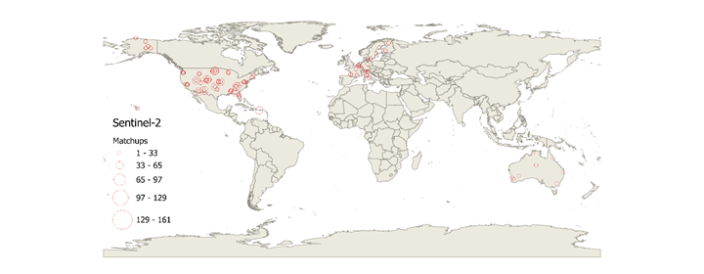
Figure 1. Placeholder for Figure 1 Error Model.

2.1 User Requirement Specification

Validation is only meaningful if user requirements are provided for conformity testing. In the context of satellite product validation, a user requirement specification defines:
- Measurands ($y$): Particular quantities subject to measurement (e.g., LAI/FAPAR).
- Parameters ($\underline{x}$): Characteristics associated with $\hat{y}$ other than $\hat{y}$ itself used to quantify influence quantities.
- Tolerance limits: intervals of limiting values that separate intervals of permissible values of the measurand from intervals of non-permissible values.

2.2.1 Measurands
LAI and FAPAR measurands must be defined in the user requirement specification. These definitions will have associated definitional uncertainty— “uncertainty arising from the finite specificity of a measurand definition” (JGCM, 2021). GCOS definitions are ambiguous due to natural variability within ecosystems (Table 3). For example, GCOS does not clearly define the condition “green” with respect to LAI or the adjective “effectively” with respect to FAPAR. CEOS has published clarifications of the GCOS definitions that identify excluded conditions and highlight known sources of uncertainty for which community consensus on quantification has not yet been achieved (Table 3; Fernandes et al., 2025a,b). Definitional uncertainty can be quantified using expert consensus or numerical simulations (JGCM calls this Type B uncertainty quantification) and incorporated in conformity tests. The validation method presented here assumes definitional uncertainty is negligible compared to product uncertainty.

Table 3. GCOS definition of LAI/FAPAR measurands (WMO, 2025) with conditions specified by CEOS (Fernandes et al., 2024a,b)
Measurand | Leaf Area Index | Fraction of Absorbed Photosynthetically  Active Radiation
Abbreviation | LAI | FAPAR
SI Symbol | None | None
SI Units¹ | 1 | 1
Definition | half the total green leaf area per unit horizontal ground area | the fraction of incoming solar radiation in the 400–700 nm spectral range that is absorbed by green elements of plants for photosynthesis
Exclusion Conditions | nonvascular organs (miss, bryophytes, green stems). Green leaves below the ground or water surface. | Plants below the ground or water surface.
Unspecified sources of uncertainty. | Definition of “green” | Definition of “green” and “effectively”  Incoming solar radiation field. Adjectives include:  Direct: direct solar illumination  Diffuse: isotropic over lower hemisphere downwelling solar radiation  Ambient: ambient downwelling solar radiation field
¹The System International dimensions of LAI and FAPAR units is “1” and are omitted (Thompson and Taylor, 2008).

Parameters

Type A validation associates each measurement condition with statistics derived from residuals based on a set of observed matchups $\left(\left\{\tilde{ y}\right\},\left\{\hat{y}\right\}\right)$ with the same or at least similar condition. Furthermore, the condition must be repeatable, in that residuals between matchups share influence quantities that “typically includes measurement procedure, measuring system, measuring system operator, operating conditions, and measurement location held fixed while performing two or more measurements over a period of time as short as necessary in order to avoid the occurrence of changes in the set of conditions” JGCM (2021). Numerous parameters correspond to influence quantities for LAI/fAPAR measurements from optical imagers (Fang et al., 2019a) but only a limited number are observed routinely coincident with ESUs with in-situ measurements and even fewer are available for the mapping unit corresponding to arbitrary product measurements (Table 4).

Table 4. Parameters used to model inclusion probability for uncertainty (all rows) and bias (only shaded rows). Parameters in italics are only available in-situ at matchup locations.
Variable | $$x_{i}$$ | $θ_{i}$ | Purpose
Land cover | Copernicus Global Land Cover | Assumed negligible | Errors due to foliage and soil optical properties and foliage vertical distribution.
LAI PM | Product LAI | LAI Uncertainty | Errors due to signal saturation and understory
FAPAR PM | Product FAPAR | FAPAR Uncertainty | Errors due to signal saturation and understory
LAI PM standard deviation | Product LAI standard deviation within validation MMU | Range of standard deviation over homogenous sites. | Spatial heterogeneity
FAPAR PM standard deviation | Product FAPAR standard deviation within validation MMU | Range of standard deviation over homogenous sites. | Spatial heterogeneity
LAI Uncertainty | Product LAI uncertainty | Product ATBD | Errors due to sensor measurement
FAPAR Uncertainty | Product FAPAR Uncertainty | Product ATBD | Errors due to sensor measurement
Annual Growing Degree Days | ERA 5 1km daily | Half total range over each site | Growing season length
Number of Days with rooting zone soil T above zero | ERA 5 1km daily | Half total range over each site | Growing season length
Annual PET/Annual P | ERA 5 1km daily | Half total range over each site | Aridity
LAI FRM | FRM LAI | FRM LAI uncertainty | Errors due to saturation or exposed soils
FAPAR FRM | FRM FAPAR | FRM FAPAR uncertainty | Errors due to saturation or exposed soils
Clumping index | FRM clumping index | FRM clumping index uncertainty | Errors due to canopy structure
Woody area index | FRM woody area index | FRM woody area index uncertainty | Errors due to optical properties

2.1.3 Tolerance Interval

GCOS requirements specify tolerance intervals for horizontal resolution, temporal resolution, uncertainty, and stability, that must be simultaneously satisfied for a measurement to be considered conforming to user requirements. GCOS does not specify tolerance intervals for accuracy.

GCOS horizontal and temporal resolution requirements constrain the spatial and temporal extent of matchups over which errors between product and reference measurements are quantified. Matchup extent must be at least as fine as the required horizontal and temporal resolution. Matchups may contain multiple associated product and reference measurements, with gaps caused by missing FDR observations or invalid retrievals. Although each associated measurement samples the matchup conditions, their spatial and temporal representativeness may vary. For example, product observations over an agricultural field may span pre-harvest and post-harvest conditions, while the reference measurement may represent only one of these states. Similarly, a measurement footprint may extend beyond the matchup because of the measurement approach or geolocation errors. Methods are required to maximize the likelihood that reference measurements

2.2 Type of Validation Adopted

Type A estimates of uncertainty and bias require residuals observed under repeatable conditions. For instruments such as clocks, parameters relevant to measurement conditions can be identified using physical models and can be controlled to sufficient extent during matchups. In contrast, , however, measurement conditions for satellite-derived LAI/FAPAR products can realistically be assumed to be identical only when product and reference measurements sample the same location and time. This assumption is often violated for decametric-resolution LAI/FAPAR products because independent replicate product and reference measurements of the same land-surface conditions within the required temporal window (e.g., 10 days) are rare. Moreover, restricting matchups to locations with multiple measurements would limit the range of conditions that can be validated and could violate the standard uncertainty assumption of independent sampling.

Instead, matchups used to estimate validation statistics for the conditions associated with a given product measurement are assumed to be independent samples from a sampling distribution of possible matchups that share the same sources of error and associated error pdf. The inclusion probability ($π_{i,j}$) is defined as the probability that the $j$th matchup shares the repeatability condition of the $i$th product measurement. This probability is assumed to be described by a prior distribution conditioned on parameters. This is a Type B validation assumption (JGCM, 2021) as it makes a prior assumption regarding distributions of conditions, that enables the Type A estimation of LAI/FAPAR product uncertainty and bias required by CEOS.

Because prior assumptions are used to model $π_{i,j}$, pure Type A validation based on the observed frequency distribution of errors is replaced by sampling from a probability distribution of matchups. The validation exercise therefore becomes a statistical experiment (Box et al., 2005). Statistical experiments comprise three components that structure the remainder of this study (Stehman and Czaplewski, 1998; Tyukavina et al., 2025):
- Sampling design: the “protocol by which the reference sample units are selected.”
- Response design: “all the steps that lead to a decision regarding the agreement between individual RM and product measurements.”
- Analysis: the procedures used to estimate validation statistics from observed differences at matchups, accounting for their associated uncertainties, and to report these estimates so that users can determine whether products meet requirements at a stated level of confidence.
The application of these three components to the validation of decametric-resolution LAI/FAPAR products is detailed in the following sections.

2.3 Sampling Design

Normally, a validation sampling design optimizes matchups location and timing to maximize the representativeness and sample independence, while satisfying constraints such as randomization and resources for FRM (Stehman and Capalesky, 1998). Current LAI/FAPAR FRM datasets are based either on manual surveys that provide measurements at multiple locations over limited periods or on fixed automated sensors that provide high-temporal-resolution observations over longer periods at limited spatial locations (Fang et al., 2019; Brown et al., 2021). Subsueqnetly, currently available matchups over these FRM can be interpreted as arising from as a non-optimal sampling design that is:
- (i) Stratified by land-cover class, and climate;
- (ii) Spatially separated to ensure approximate independence; and
- (iii) Representative of random sampling, since valid product retrieval timing is generally independent of in-situ measurement errors.

2.3.1 Modeling Inclusion Probabilities

We model $π_{i,j}$ as an uncorrelated multivariate Normal probability density function (pdf) of parameters ${\underline{x}}_{j}$ of the $j$th measurement, with mean defined as the ${\underline{x}}_{i}$ of the $i$th matchup with variance vector ${\underline{θ}}_{i}$ is specified using expert knowledge and modelling studies of the sources of error:

$π_{i,j}=N\left({\underline{x}}_{j} | {\underline{x}}_{i},{\underline{θ}}_{i}\right)$ (1)

An uncorrelated distribution is used to reduce the sensitivity of $π_{i,j}$ to parameter measurement error and due to insufficient knowledge regarding the influence of covarying parameters . Inclusion probabilities estimated for parameters without in-situ data are denoted ${\hat{π}}_{i,j}$.

This approach to modelling inclusion probability assumes residuals observed for ${\underline{x}}_{i}$ can be observed for conditions ${\underline{x}}_{j}$ with non-zero probability. This is not always the case as, for example, for a product algorithm that limits measurement estimates of LAI between 0 and 10, the residual for a ESU where the reference LAI is 5 may never exceed 5. To increase the likelihood that inclusion probabilities are representative of the similarity of conditions between two measurements we set ${\hat{π}}_{i,j}=0$ if it falls below a minimum level $π_{min}$. A practical estimate of $π_{min}$ corresponds to the minimum of inclusion probabilities observed for conditions in the same site:

${\hat{π}}_{min}=\min_{\left.∀i,j\right|site}{inf\left[{\hat{π}}_{i,j},π_{i,j}\right]}$ (2)

2.4 Response Design

The response design defines how residuals are estimated for a matchup. While previous validation practices focused on hectometric LAI/FAPAR products with single coincident measurements, decametric-resolution products often feature finer spatial resolutions and temporal sampling that may not exactly match reference measurement times (Fernandes et al., 2014; Brown et al., 2024; Camacho et al., 2025).

Although direct comparisons between product measurements and FRM may reduce spatial scaling uncertainties, heterogeneous landscapes can introduce rapid temporal disturbances or spatial variability that may bias validation statistics. Sample specific estimates of measurement footprint and high-resolution ancillary data (e.g. Brown et al., 2020; Lanconelli et al., 2024;) is rarely feasible or consistently documented across networks. Instead, we use robust estimators of the expected value of residuals between FRM and product measurements within a matchup.

Note that the standard error (symbol $s)$ is the standard deviation of statistic of a sampling distribution. More generally, the one standard deviation confidence interval (hereafter simply confidence interval) of a quantity (symbol $σ)$ is a measure of dispersion that applies to all estimated quantities and not just statistics. Note that the one confidence interval is synonymous with the standard uncertainty when referring to the product measurements or FRM.

2.4.1 FRM Estimate

For a matchup $\left(\left\{\tilde{ y}\right\},\left\{\hat{y}\right\}\right)$ within an ESU for day $d$ , the FRM expected value (${\tilde{ y}}_{d}$) and standard errors (${\tilde{ s}}_{d}$) is estimated as:

${\tilde{ y}}_{d}=\sum_{{\tilde{ y}}_{i} ∈\left\{\tilde{ y}\right\}}{{\tilde{w}}_{i}{\tilde{ y}}_{i}}$ (3)

${\tilde{ s}}_{d}=\sqrt{\frac{1}{\sum_{{\tilde{ y}}_{i} ∈\left\{\tilde{ y}\right\}}{{\tilde{w}}_{i}}}}$ (4)

where, given a prior estimate of the standard uncertainty for each ${\tilde{ y}}_{i}$ (${\tilde{ σ}}_{i}$):
${\tilde{w}}_{i}=\frac{1}{{\tilde{σ}}_{i}^{2}}$ (5)

2.4.2 Daily Error Calculation

Assuming each ${\hat{y}}_{i}$ samples the same conditions that give rise to the FRM, ${\tilde{ y}}_{d},$the residual between ${\hat{y}}_{i}$ and a FRM is:

${{\hat{r}}_{i,d}=\hat{y}}_{i}-{\tilde{ y}}_{d}$ (6)

with confidence interval corresponding to the Euclidean sum of ${\tilde{ σ}}_{d}$ and a prior estimate of measurement standard uncertainty (${\hat{σ}}_{i}^{}$):

${\hat{σ}}_{r}^{}=\sqrt{{\hat{σ}}_{i}^{2}+{\tilde{s}}_{d}^{2}}$ (7)
The residual between $\left\{\hat{y}\right\}$ and ${\tilde{ y}}_{d}$ for day $d$ (${\overset{ˆ}{r}}_{d}$) is estimated using a weighted median of differences:

${\hat{r}}_{d}=\underset{∀i}{MdnW}\left({\hat{r}}_{i,d},{\hat{w}}_{i}\right)$ (8)

With
${\hat{w}}_{i}=\frac{1}{{\hat{σ}}_{r}^{}}$ (9)

The weighted median difference is used rather than the weighted mean to reduce the influence of geolocation and temporal mismatches and within ESU heterogeneity on ${\hat{r}}_{d}.$ The standard error of ${\overset{ˆ}{r}}_{d}$ (${\hat{s}}_{{\hat{r}}_{d}}^{})$is estimated as the half-width of the 67.5% confidence interval of the weighted median (Allouche and Gobet, 2025) with effective number of degrees of freedom:

${\hat{n}}_{i}=\frac{{\left(\sum_{i=1}^{n}{w_{i}}\right)}^{2}}{\sum_{i=1}^{n}{w_{i}^{2}}}$ (10)

The confidence interval of ${\hat{r}}_{d}, {\hat{σ}}_{{\hat{r}}_{d}}^{}$, corresponds to the Eucluidean sum of the standard error due to sampling and the error due to uncertainty in individual residuals:

${\hat{σ}}_{{\hat{r}}_{d}}^{}=\sqrt{{\hat{s}}_{{\hat{r}}_{d}}^{2}+\frac{{\hat{σ}}_{r}^{}}{{\hat{n}}_{i}}}$ (11)

2.4.3 Temporal Aggregation and Total Error

To minimize the impact of geolocation errors and residual image artifacts (e.g. atmospheric effects , shadows) the error for time interval $T$ (${\hat{e}}_{T}$) is estimated as the minimum daily error observed in the interval:

${\hat{e}}_{T} =\min_{d∈T}\left({\hat{r}}_{d}\right)$ (12)

Assuming ${\overset{ˆ}{e}}_{d}$ values are outliers-free, the standard error of ${\overset{ˆ}{e}}_{T}$ due to temporal variability in conditions (${\overset{ˆ}{s}}_{T}$) is modelled assuming the range of ${\overset{ˆ}{e}}_{d}$ within $T$ corresponds an uncertainty interval of +/-2 standard deviations:

${\overset{ˆ}{s}}_{T}=\frac{\max_{d∈T}\left({\overset{ˆ}{e}}_{d}\right)-\min_{d∈T}\left({\overset{ˆ}{e}}_{d}\right)}{4}$ (13)

The confidence interval of ${\hat{e}}_{T}$(${\hat{σ}}_{{\hat{e}}_{T}})$ is estimated as the Euclidean sum of the sample median standard error and the temporal variability standard error:
${\hat{σ}}_{{\hat{e}}_{T}}=\sqrt{{\hat{s}}_{r}^{2}+{\hat{s}}_{{\hat{e}}_{d}}^{2}+{\hat{σ}}_{T}^{2}}$ (14)

2.5 Analysis Design

The analysis design tests product conformity with user requirements using thematic quality statistics derived from observed errors, standard uncertainties, and matchup parameters. Validating GCOS thematic quality requirements requires quantifying relative standard uncertainty, standard uncertainty, and stability statistics. These statistics require an explicit estimate of bias: stability evaluates changes in bias over time, while uncertainty requires subtracting bias from errors if it is non-negligible compared to uncertainty (JCGM, 2021).

2.5.1 Bias

The bias for the ith measurement (${\overset{ˆ}{b}}_{i}$) is estimated using the weighted median of errors across all matchups as long as the median inclusion probability exceeds ${\hat{π}}_{min}$:

${\hat{b}}_{i}=\left\{\begin{matrix}\underset{∀j=1…n}{MdnW}\left({\hat{e}}_{j},w_{i,j}\right) & \max_{∀j=1…n}{ {\hat{π}}_{i,j}>{\hat{π}}_{min}} \\ undefined & else\end{matrix}\right.$ (15)

where the weights${ w}_{i,j}$ account for both the inclusion probability and the standard uncertainty of the estimated error for each matchup:

$w_{i,j}=\frac{1}{\sum_{j=1}^{n}{\left(\frac{ {\hat{π}}_{i,j}}{{\hat{σ}}_{{\hat{e}}_{j}}^{2}}\right)}}\frac{ {\hat{π}}_{i,j}}{{\hat{σ}}_{{\hat{e}}_{j}}^{2}}$ (16)

The confidence interval of ${\hat{b}}_{i}$ ($σ_{{\hat{b}}_{i}})$ is estimated as the Euclidean sum of the standard error of the weighted median due to limited sampling (${\hat{s}}_{{\hat{b}}_{i}}$ ), the confidence interval of estimating errors (${\hat{σ}}_{{\hat{e}}_{i}}^{}$) , and the error due to the use of $\hat{π}$ rather than $π$ for uncertainty estimation (${\hat{δ}}_{{\hat{b}}_{i}})$:

$σ_{{\hat{b}}_{i}}=\sqrt{{\hat{s}}_{{\hat{b}}_{i}}^{2}+{\hat{σ}}_{{\hat{e}}_{i}}^{2}+{\hat{δ}}_{{\hat{b}}_{i}}^{2}}$ (17)

Where ${\hat{s}}_{{\hat{b}}_{i}}$ is estimated as the half width of the 67.5%ile confidence interval of the weighted median(${\hat{σ}}_{{\hat{b}}_{i}}$ ) sites (Allouche and Gobet, 2025) .

Here, ${\hat{δ}}_{{\hat{b}}_{i}}$was estimated as the weighted median absolute difference between bias estimated using $\hat{π}$ rather than $π$ over all matchups:

${\hat{δ}}_{{\hat{b}}_{i}} =\left\{\begin{matrix}\underset{j=1…n}{MdnW}\left(\left|{\hat{b}}_{j}-{\hat{b}}_{j}\right|,w_{i,j}\right) & \max_{∀j=1…n}{ {\hat{π}}_{i,j}>{\hat{π}}_{min}} \\ undefined & else\end{matrix}\right.$ (18)

Where ${\hat{b}}_{j}$ is derived using Equation 15 replacing $\hat{π}$with $π$ .

2.5.2 Standard Uncertainty

The standard uncertainty of of ${\hat{y}}_{i}$ is estimated as the weighted median absolute deviation of bias corrected errors observed for all $n$ matchups, scaled by 1.4826 to account for the difference between the median absolute deviation and standard deviation assuming normally distributed errors, and adjusted for reference measurement standard error (${\hat{s}}_{{\check{y}}_{i}}^{}$):

${\hat{u}}_{i}=\left\{\begin{matrix}\sqrt{{\left[1.4826\underset{j=1…n}{MdnW}\left({\hat{e}}_{j}-{\hat{b}}_{j},w_{i,j}\right)\right]}^{2}-{\hat{s}}_{{\check{y}}_{i}}^{2}} & \max_{∀j=1…n}{ {\hat{π}}_{i,j}>{\hat{π}}_{min}} \\ undefined & else\end{matrix}\right.$ (19)

The confidence interval of ${\hat{u}}_{i}$ ($σ_{{\hat{u}}_{i}})$ is estimated as the Euclidean sum of the standard error of estimate of the weighted median (${\hat{s}}_{{\hat{u}}_{i}}^{}$ ) the confidence interval of ${\hat{b}}_{j}$ and the and the error due to the use of $\hat{π}$rather than $π$ for uncertainty estimation (${\hat{δ}}_{{\hat{u}}_{i}}$ ) and

$σ_{{\hat{u}}_{i}}=\sqrt{{\hat{s}}_{{\hat{u}}_{i}}^{2}+{\hat{δ}}_{{\hat{u}}_{i}}^{2}+{\hat{σ}}_{{\hat{b}}_{j}}^{2}}$ (20)

Where ${\hat{s}}_{{\hat{u}}_{i}}^{}$ was estimated as the Euclidean sum of the numerically determined 67.5% confidence interval of the weighted median of errors.

Here, ${\hat{δ}}_{{\hat{u}}_{i}}$was estimated as the weighted median absolute difference between standard uncrtaiinty using $\hat{π}$ rather than $π$ over all matchups:

${\hat{δ}}_{{\hat{u}}_{i}} =\left\{\begin{matrix}\underset{j=1…n}{MdnW}\left(\left|{\hat{u}}_{j}-{\hat{u}}_{j}\right|,w_{i,j}\right) & \max_{∀j=1…n}{ {\hat{π}}_{i,j}>{\hat{π}}_{min}} \\ undefined & else\end{matrix}\right.$ (21)

Where ${\hat{u}}_{j}$ is derived using Equation 19 replacing $\hat{π}$with $π$ .

2.5.3 Relative Standard Uncertainty

The relative standard uncertainty of the i^{th} measurement is estimated is estimated as

${\hat{u}}_{r,i}=\frac{{\hat{u}}_{i}}{{\hat{y}}_{i}}$ (22)

The n confidence interval of ${\hat{u}}_{r,i}$ (${\hat{σ}}_{{\hat{u}}_{r,i}}$) is estimated as:

${\hat{σ}}_{{\hat{u}}_{r,i}}={\hat{u}}_{r,i}\sqrt{{\left(\frac{{\hat{σ}}_{{\hat{u}}_{i}}}{{\hat{u}}_{i}}\right)}^{2}+{\left(\frac{{\hat{s}}_{{\check{y}}_{i}}^{}}{{\hat{y}}_{i}}\right)}^{2}}$ (23)

2.5.4 Stability

Stability requires quantifying the change in bias between two years ($Y_{k},Y_{l})$ for a matchup condition , excluding instrument-related influence quantities. While measurement stability is often characterized under controlled conditions (e.g., Pai et al., 2015), this is generally unfeasible for the wide range of conditions experienced by LAI/FAPAR products over multiple years.

Instead, the bias at the ith measurement is estimated for any year $Y$ (${\hat{b}}_{i}\left(Y\right)$) by setting $π\left({\underline{x}}_{j} | {\underline{x}}_{i}\right)=0$ if $Y_{j}≠Y_{i}$ . The stability for the ith measurement is then estimated as the weighted median of stability for all pairwise combinations $Y_{k},Y_{l}$,

$\hat{S}=\underset{k≠l}{MdnW}\left(\left|{\hat{S}}_{k,l}\right|,ω_{k,l}\right)$ (24)

where

${\hat{S}}_{k,l}=\frac{{\hat{b}}_{i}\left(Y_{l}\right)-{\hat{b}}_{i}\left(Y_{k}\right)}{{\hat{b}}_{i}\left(Y_{k}\right)×\left(Y_{l}-Y_{k}\right)}$ (25)

and the weight $ω_{k,l}$, is inversely proportional to the squared confidence interval ${\hat{σ}}_{k,l}$:

${\hat{σ}}_{k,l}=\frac{\hat{b}\left(Y_{l}\right)}{\hat{b}\left(Y_{k}\right)} \sqrt{{\left(\frac{{\hat{σ}}_{\hat{b}\left(Y_{l}\right)}}{\hat{b}\left(Y_{l}\right)}\right)}^{2}+{\left(\frac{{\hat{σ}}_{\hat{b}\left(Y_{k}\right)}}{\hat{b}\left(Y_{k}\right)}\right)}^{2}}$ (26)

2.5.5 Conformity Testing

Conformity associates a probability that an estimated statistic for a measurement meets tolerance intervals. This entails two aspects:

- Representativeness: The statistic must be representative of the measurement. The representativeness of a statistic associated with a measurement is quantified here as the maximum inclusion probability with an interval of uncertainty for this estimate based on the standard deviation of the sensitivity of inclusion probabilities to the absence of in-situ information.

- Conformance probability: The conformance probability ($p_{c}$) is the probability that a product, item, or process fulfills a specified requirement (JGCM, 2012) . Here, the requirements correspond to tolerance intervals. The conformance probability is quantified as the cumulative probability validation statistics (e.g. standard uncertainty, stability) fall tolerance intervals corresponding to threshold requirements. Here, $p_{c}$ is modelled assuming truncated uncorrelated bivariate normal distribution for the product measurement and the associated validate statistic (standard uncertainty, stability) with standard deviations specified by the product measurement standard uncertainty and the validation statistic standard uncertainty (e.g. Figure 1).

- 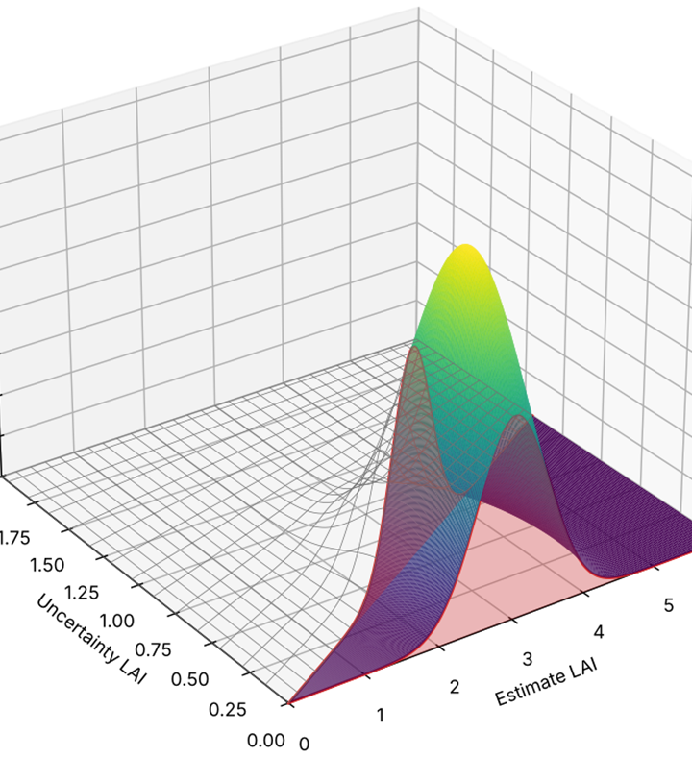
Figure 2. Estimating the probability of conforming with LAI uncertainty requirements for a measurement (LAI 3 , standard uncertainty 0.5, and one standard distribution confidence interval for the uncertainty estimate of 0.3) as the probability mass of the estimated statistics (here uncertainty LAI) satisfying user requirements.

Materials

3.1 In-Situ Fiducial Reference Measurements

3.1.1 Dataset and Study Sites

The GROUNDED EO database (Brown et al., 2025), comprising 9,382 paired LAI/FAPAR estimates from 1,087 ESUs across 71 sites in Australia (TERN), Europe (ICOS), and the United States (NEON) comprise the FRM used here (Figure 3). Sites are stratified by ecological diversity within each network. Sites included land cover using the National Land Cover Database (NLCD) legend woody area index (WAI), and canopy clumping index surveyed using methods ( Brown et al. 2025) that enable fiducial reference measurements of LAI and FAPAR with uncertainties traceable to community standards (Brown et al., 2021a).

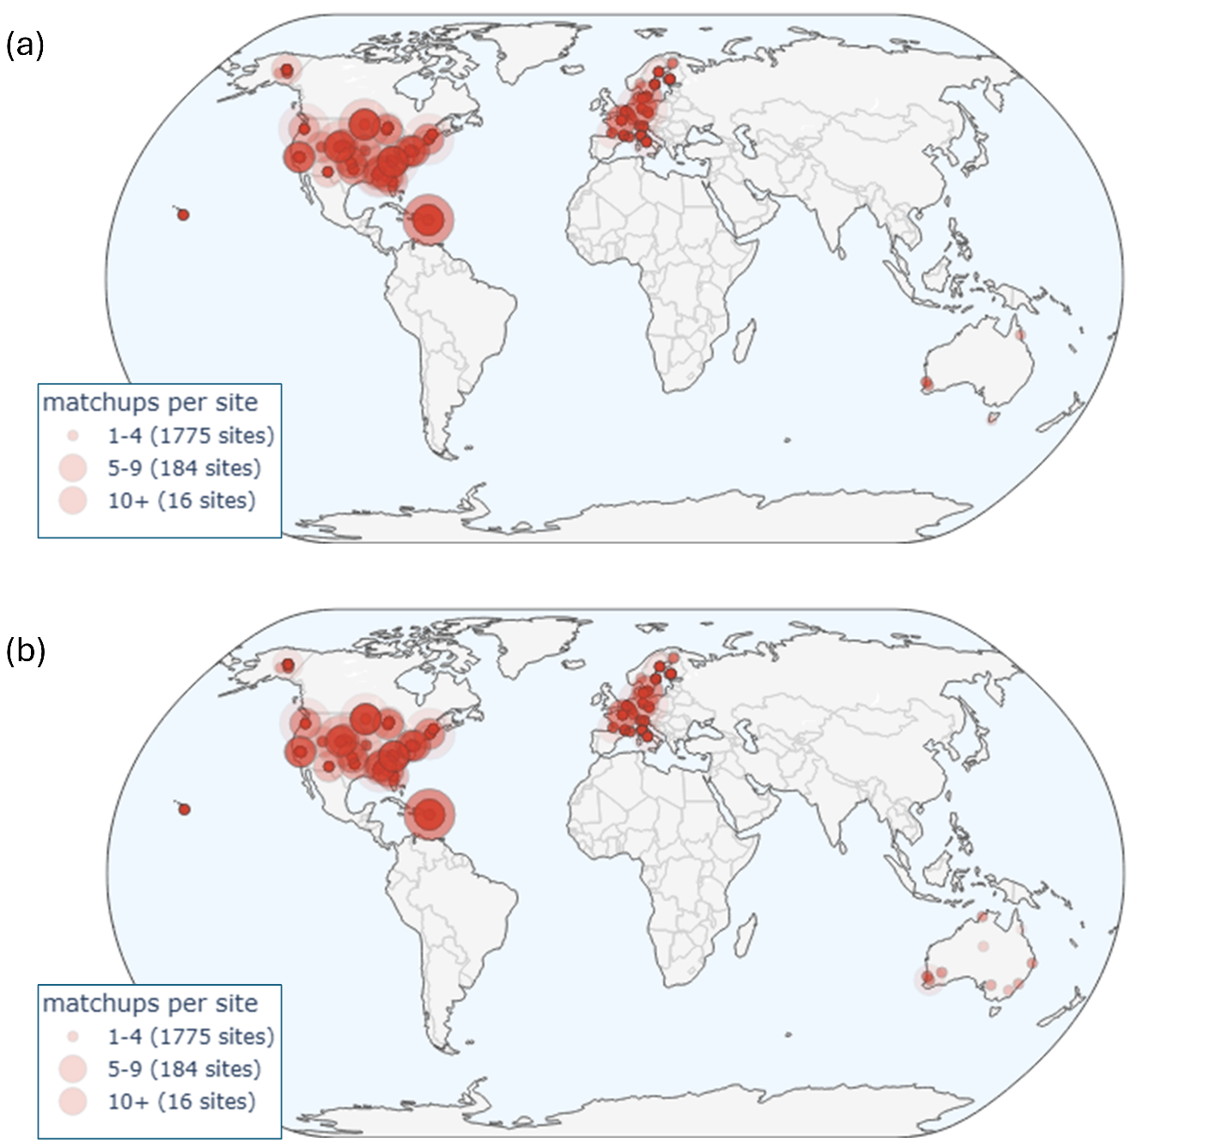
Figure 3. Number of matchups per GroundedEO site for (a) HLS L30 and (b) HLS S30..

3.1.2 Data Quality and WAI Correction

Exploratory data analysis identified 62 ESUs across seven forest sites with unrealistically low WAI values corresponding to land cover default values from Brown et al. (2021b) rather than plot-specific measurements. These values were replaced with linear regression estimates of WAI as a function of PAI, calibrated using paired WAI and PAI measurements from all other sites with the same land-cover type (Brown et al., 2024). The uncertainty of the affected LAI estimates was revised by substituting the nominal WAI standard uncertainty (Brown et al., 2021) with the one-standard-deviation regression prediction confidence interval.

3.1.3 Spatial Heterogeneity Assessment

ESUs were visually assessed for spatial heterogeneity of land cover and fraction of vegetation cover using the most recent high resolution ESRI World Imagery and Google Earth Pro imagery available (e.g. Figure 4). Sites were qualitatively classified into three categories:
- Homogeneous within a 60 m radius of the ESU centroid;
- Homogeneous within a 30 m radius, but heterogeneous between 30 m and 60 m.
- Heterogeneous within a 30 m radius; or
The 30 m radius approximates the spatial support of the in-situ measurements. The 60 m radius encompasses a $3×3$ patch of nominal 30 m Harmonized Landsat and Sentinel-2 (HLS) pixels, accommodating worst-case geolocation errors (see Section 3.3).

Table 5. Description of in-situ FRM networks. Values in brackets correspond to cases that include at least 1 matchup.
 | Network
 | ICOS | NEON | TERN
Spatial Extent | European Union, UK | United States of America | Australia
Start Date | 2017 | 2013 | 2011
End Date | 2022 | 2022 | 2023
#Sites | 20 (20) | 47 (45) | 14 (14)
#ESUs | 420 (324) | 947 (821) | 21 (19)
#FRM | 1776 (1442) | 11464 (10013) | 154 (146)
#ESUs intraannual | 54 (44) | 144 (121) | 4 (4)

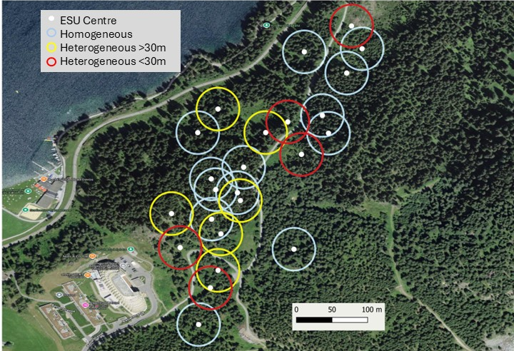
Figure 4. Visually assessed ESU spatial heterogeneity at the Davos ICOS site. ESU centres indicated by solid white circles. Hollow circles indicate 30m radius neighbourhood around each ESU.

3.2 Land cover

The10m resolution circa 2020 ESA WorldCover 10m v200 (Zanga et al., 2021) was used to specify other vegetation, non-vegetation, and forest land cover groups. The forest land cover group was subdivided into broadleaf and needle leaf forests using the 30m resolution Land Cover of North America NALCMS 2020 (Commission for Environmental Cooperation, 2023) over North America and, the 2019 100m resolution Copernicus Global Land Cover Layers: CGLS-LC100 Collection 3 (Buchhorn et al., 2020 ) elsewhere (Table 6).

Table 6 Land cover group definition.
WorldCover | NALCMS 2020 | CGLS LC100 | NLCD Class | Group
Tree cover | Temperate or sub-polar needleleaf forest  Sub-polar taiga needleleaf forest | Closed forest, evergreen needle leaf.  Closed forest, deciduous needle leaf  Open forest, evergreen needle leaf.  Open forest, deciduous needle leaf. | Evergreen forest  Mixed Forest | NF
Tree cover | Not needle leaf classes | Not need leaf classes | Deciduous Forest  Woody wetlands | BF
Shrubland |  |  | Shrub Scrub | OV
Grassland |  |  | Grassland/Herbaceous  Pasture/hay | OV
Cropland |  |  | Cultivated Crops | OV
Built-up |  | Developed | Developed | NV
Bare / sparse vegetation |  | Barren Land | Barren Land  Dwarf Scrub | OV
Snow and ice |  | Perennial snow/ice cover | Perennial snow/ice cover | NV
Permanent water bodies |  | Open water | Open water | NV
Herbaceous wetland |  |  | Sedge Herbaceous  Emergent Herbaceous Wetlands | OV
Mangroves |  |  |  | BF
Moss and lichen |  |  | Lichens  Moss | OV

3.3 Fundamental Data Records

FDRs corresponded to all 30m resolution clear-sky snow and water free land HLS Nadir Bidirectional Reflectance Distribution Function Adjusted Reflectance (NBAR) measurements from the Landsat 8 and 9 OLI from 11/04/2013 onwards from the Google Earth Engine https://developers.google.com/earth-engine/datasets/catalog/NASA_HLS_HLSL30_v002 collection (HLS L30) and Sentinel 2a,b,c Multispectral Instrument from https://developers.google.com/earth-engine/datasets/catalog/NASA_HLS_HLSS30_v002 (HL S30) from 28/11/2015, intersecting ta 60m radius buffer centred on each ESU and also on a global 100km x 100km grid.

Measurements were retained only if the FMASK layer indicated low-aerosol, cloud-free, and cloud-shadow-free conditions. Measurements flagged with snow or water were discarded, as these conditions are excluded from the FRM.

3.4 Product Measurements

LAI and FAPAR were estimated for clear-sky FDRs globally and at matchup locations by applying the Simplified Level 2 Prototype (SL2P) algorithm (Weiss et al., 2020) to spectral and geometry bands gridded at 20m resolution.

3.4.1 Algorithm Selection: SL2P

While numerous algorithms exist for generating decametric LAI/FAPAR products from systematic FDRs (CEOS, 2025), SL2P was selected because it is:
- Independent of FRM.
- Globally applicable to both Landsat 8/9 OLI and Sentinel-2 MSI decametric FDRs;
- Provides associated theoretical uncertainty estimates with each measurement; and
- Avalable as open-source code (Djamai et al., 2024 )

3.4.2 SL2P Architecture and Training

SL2P employs separate sensor-specific, single-hidden-layer neural networks to estimate LAI, FAPAR, and their theoretical uncertainties (${\overset{ˆ}{u}}_{\text{LAI}}$ and ${\overset{ˆ}{u}}_{\text{FAPAR}}$) using a subset of OLI or MSI surface reflectance bands (Table 3). The networks are trained on a calibration database of 42,748 simulated reflectance spectra sampled randomly across nominal OLI acquisition geometry (for HLS L30 products) or Sentinel 2A MSI spectral bands and sampled randomly across nominal S2A MSI acquisition geometry (for HLS S30 products). Theoretical uncertainties, representing the standard uncertainty of estimates derived from hold-out cross-validation using an independent simulation database, combined with nominal FDR measurement errors, were also estimated for each product measurement.

3.4.3 Simulation and Quality Filtering

Surface conditions for each simulation are drawn via orthogonal sampling from a joint distribution of vegetation structure and optical properties (leaf and soil), fitted to global pre-algorithm in-situ and in-vivo measurements. Reflectance is simulated using the 4SAIL canopy reflectance model and the PROSPECT-D leaf optical model, incorporating additive and multiplicative noise corresponding to nominal sensor uncertainties (see Weiss et al., 2020). SL2P estimates were discarded if the input reflectance does not match at least one calibration sample within 0.05 in each band or the output estimate exceeds the range of the calibration database.

3.5 Climate Data

Gridded daily 1.1312 km resolution ERA5-Land Daily Aggregated - ECMWF Climate Reanalysis (Muñoz Sabater et al., 2021) layers, archived in Google Earth Engine, were sampled to produce annual climate parameters spatially coincident with thematic data products:
- GDD: Total annual degree days above a base temperature of 10°C;
- FROST: Total number of days in a year with a daily minimum soil temperature (0–7 cm depth) greater than 0°C; and
- ARIDITY: Ratio of annual potential evapotranspiration to annual precipitation.
The uncertainty for GDD, FROST, and ARIDITY was estimated as their temporal range for the same calendar date between 2013 to 2025 inclusive.

4. Results

4.1 Validation

A total of 4245 HLS L30 matchups and 4285 HLS S30 matchups were observed within +/-7d of in-situ measurements and 874 HLS L30 matchups and 872 HLS S30 matchups for a +/-1 d window. Matchups were observed at all sites (Figure 3) although the majority (80 %) were within the continental US due to the longer temporal extent of the NEON FRM network compared to European and Australian networks. For brevity, only HLS L30 validation results for +/-7d matchup intervals across all sites are presented in detail with sensitivity analyses provided to heterogeneity and temporal sampling included in Supplementary Material S3.

As noted in previous validation studies using Grounded EO FRM (Brown et al., 2021b, Fernandes et a., 2024) , matchup land cover was non-uniformly distributed across SL2P estimates of LAI and FAPAR , with high SL2P estimates mainly associated with forest cover (Figure 5a,b). Clumping index and woody area index were also distributed in a non-uniform manner for a given LAI or FAPAR FRM (Figure 5c,d,e,f), both because these are generally higher for forests versus other land cover and because the GroundedEO forest FRM were generally for mature forests where clumping index can be higher due to canopy closure and woody area index is also higher due to accumulated standing woody matter over time.
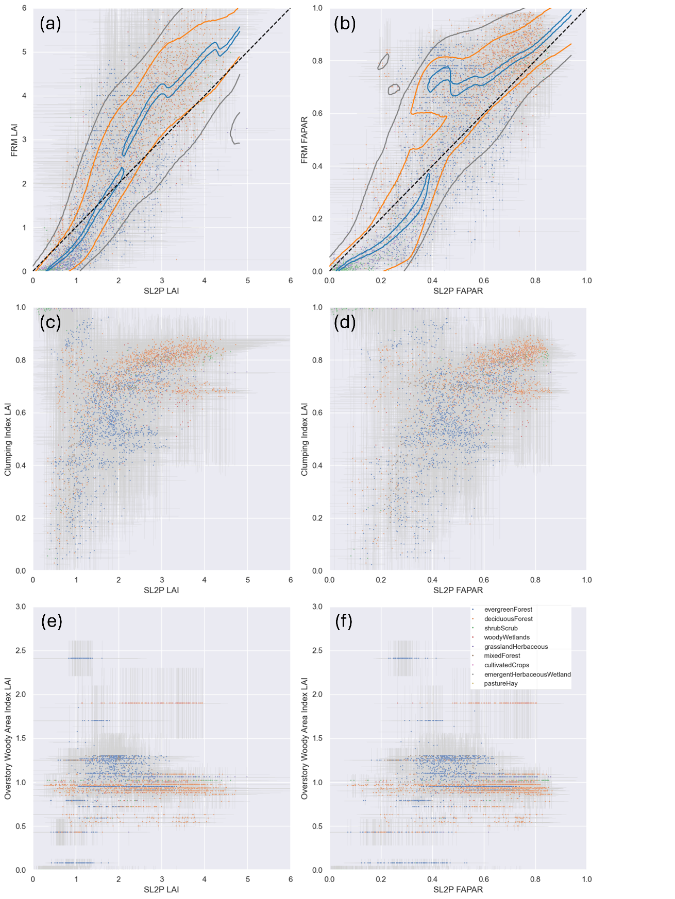
Figure 5. Scatter plot of HLS Estimates for (a) FRM LAI (c ) FRM clumping index, e) FRM woody area index versus SL2P LAI and (b) FRM FAPAR (d ) FRM clumping index, f) FRM woody area index versus SL2P FAPAR, coloured by land cover class. Contours indicate 0.1 (blue),, 0.67 (orange) and 0.90 (grey) cumulative conditional probability of bias given FRM. Whiskers in panels (a) and (b) indicate one standard deviation intervals of estimates or FRM. Common land cover legend included in panel (f).

4.2 Bias

SL2P LAI typically overestimated FRM for SL2P LAI <2 and underestimated FRM for SL2P LAI>2 (Figure 6a). Similarly, SL2P estimates for FAPAR typically overestimated FRM for FAPAR <0.4 and underestimation FRM for FAPAR>0.4 (Figure 6b). These biases are not always evident for single matchups or even matchups for a single land cover but are clear from contours of condition marginal distributions of bias given SL2P estimates. These contours also indicate breakpoints where bias changes from underestimation to overestimation. The dispersion of FAPAR bias was generally greater than that of LAI bias both in terms of the width of the interval of conditional bias given the product measurement (e.g. orange contours for 67%ile interval) and the confidence interval of estimated bias (vertical whiskers). Visual assessment suggests that bias correction is generally effective for LAI (of Figure 6c) and FAPAR except for FRM FAPAR>0.9 where matchups are limited. (Figure 6d).

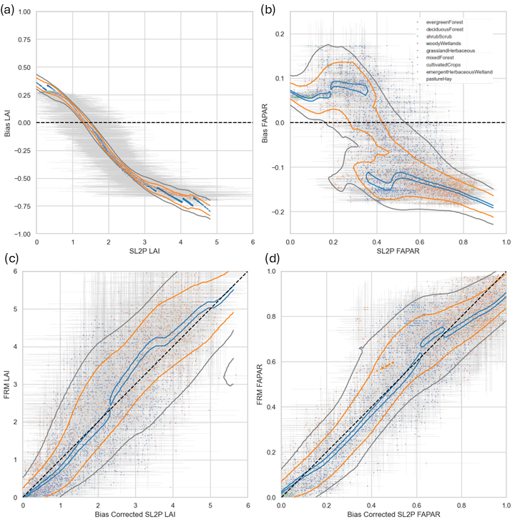
Figure 6. Scatter plots of (a) LAI bias (b) FAPAR bias as a function of S2P LAI and (c) FRM LAI versus bias corrected SL2P LAI and (b) FRM FAPAR versus bias corrected SL2P FAPAR. Contours indicate 0.1 (blue),, 0.67 (orange) and 0.90 (grey) cumulative conditional probability of bias given FRM. . Whiskers indicate one standard deviation intervals of estimates or FRM.

4.3 Uncertainty

Conditional distributions of uncertainty given the SL2P estimate are evaluated both because modelling studies suggest uncertainty should increase with increasing LAI (Weiss et al., 2020)and because GCOS user requirements include relative standard uncertaintie. Uncertainty ranged from 0 to ~2 for LAI and 0 to ~0.2 for FAPAR for individual matchup, with expected values for individual matchups (scatter plot points) exceeding GCOS requirements about half the time for LAI (Figure 7a) and for the majority of FAPAR retrievals (Figure 7c). However, the one standard deviation intervals for individual LAI and FAPAR uncertainty estimates (whiskers in Figure 7a,c) was large, approaching +/-1 LAI and +/-0.2 FAPAR in some cases, and typically of similar magnitude to the range of uncertainty estimates across matchups for a given level of SL2P estimates (grey contours in Figure 7a,c) . As a result, validating or comparing products uncertainty must both account for estimation errors to and consider distributions of estimates across matchups to have useful levels of statistical confidence.

Conditional distributions of uncertainty for LAI (Figure 7a) and FAPAR (Figure 7c) increase for low S2LP estimates (SL2P LAI<2 , SL2P FAPAR<0.3) and level off at and expected value of uncertainty of ~0.5 LAI and ~0.05 FAPAR, respectively. However, there is significant between matchup variability in uncertainty. For LAI, uncertainty ranged from ~0.25 to ~0.75 for the central 67%ile conditional intervals and from ~0 to ~1 for the 90%ile. The situation for FAPAR is more complicated in that while the lower 67%ile of conditional uncertainty is ~0.025 the upper 67%ile interval includes a mode at SL2P FAPAR 0.5 that with uncertainty exceeding 0.1.

4.4 Stability

Stability estimates for individual matchups ranged from +/-0.02 yr⁻¹ for both LAI (Figure 7b) and FAPAR (Figure 7d) . These estimate fell within GCOS FAPAR requirements even considering the estimation intervals for FAPAR uncertainty (whiskers in Figure 7d). As a result, stability for FAPAR could be evaluated for individual matchups but conditional distributions are considered for consistency between LAI and FAPAR validation methods. Conditional distributions of stability given SL2P estimates indicate LAI stability gets worse (increasing magnitude of the staistics) with increasing LAI, reaching 0.01yr⁻¹ at SL2P LAI 5 but FAPAR stability was essentially constant with SL2P FAPAR. That said, LAI stability did show a mode of poor stability (0.02 yr⁻¹) at SL2P LAI 3 corresponding to forest sites in a mountainous region of western US where forest fires are frequent (NEON sites in the Pacific Southwest of the US). Both the presence of atmospheric haze from fires and terrain effects may have contributed to increased interannual biases in input reflectance to SL2P for these locations.

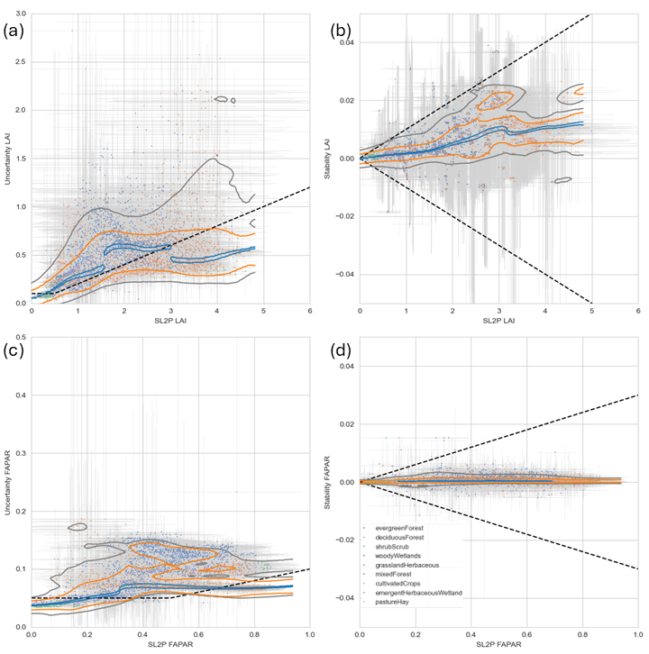
Figure 7. Scatter plot of HLS Estimates for (a) LAI uncertainty, (b) LAI stability, (c) FAPAR uncertainty, (d) FAPAR stability versus FRM over matchups. Dashed lines correspond to modified GCOS threshold requirements. Contours indicate 0.1 (blue), 0.67 (orange) and 0.90 (grey) cumulative conditional probability of bias given FRM. . Whiskers indicate one standard deviation intervals of estimates or FRM.

4.5 Conformity

Over matchups, $p_{c}$ for uncertainty was generally very low for both LAI (<0.2,Figure 8a) and FAPAR (<0.1, Figure 8c ). The relatively large intervals for both SL2P estimates and validation statistics (whiskers in Figure 7 ) reduce the actual probability of conformity even for matchups whose expected values satisfy GCOC requirements. Additionally, intervals for estimates of uncertainty have an asymmetric effect since they are truncated at zero so the upper interval tends to reduce conformity probability more than the lower interval increases $p_{c}$ Only LAI conformity for non forested land cover matchups showed $p_{c}>0.5$ suggesting that random errors over crops and grasslands may be lower than forests due to their lower structural diversity. FAPAR $p_{c}$ for uncertainty was also <0.1 due to the extremely stringent GCOS requirements for relative standard uncertainty.

For stability, $p_{c}$ was generally above 0.5 for both LAI ( Figure 8b) and FAPAR (Figure 8d ) and for the majority of matchups above 0.9. The exception for FAPAR being, some shrubs and mixed forest matchups with lower conformity probabilities for FAPAR stability ($p_{c}<0.5$ ) compared to other matchups due to having only 5 years with matchups versus up to 12 years in the best case. The exception for LAI being some forests where $p_{c}$ dropped to as low as 0.2 where this was due to actual variability in bias rather than limited temporal sampling.

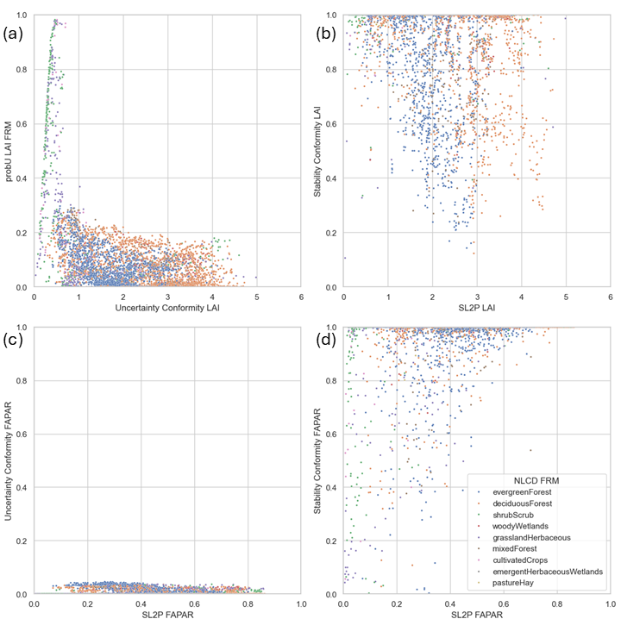
Figure 8. Probability of conforming with GCOS threshold requirements for (a) LAI uncertainty, (b) LAI stability, (c) FAPAR uncertainty, (d) FAPAR stability for individual matchups.

The sensitivity of , $p_{c}$ to the uncertainty in estimating validation statistics and product measurements was by estimating $p_{c}$ assuming the expected value of estimated validation statistics to zero . Even with this optimistic assumption the conformity probability for LAI and FAPAR uncertainty for forest matchups only ranged from 0 to 0.8 (Figure 9a,c). In contrast, conformity probabilities for stability stay relatively unchanged suggesting the available matchups are sufficient to test stability requirements (Figure 9b,d).

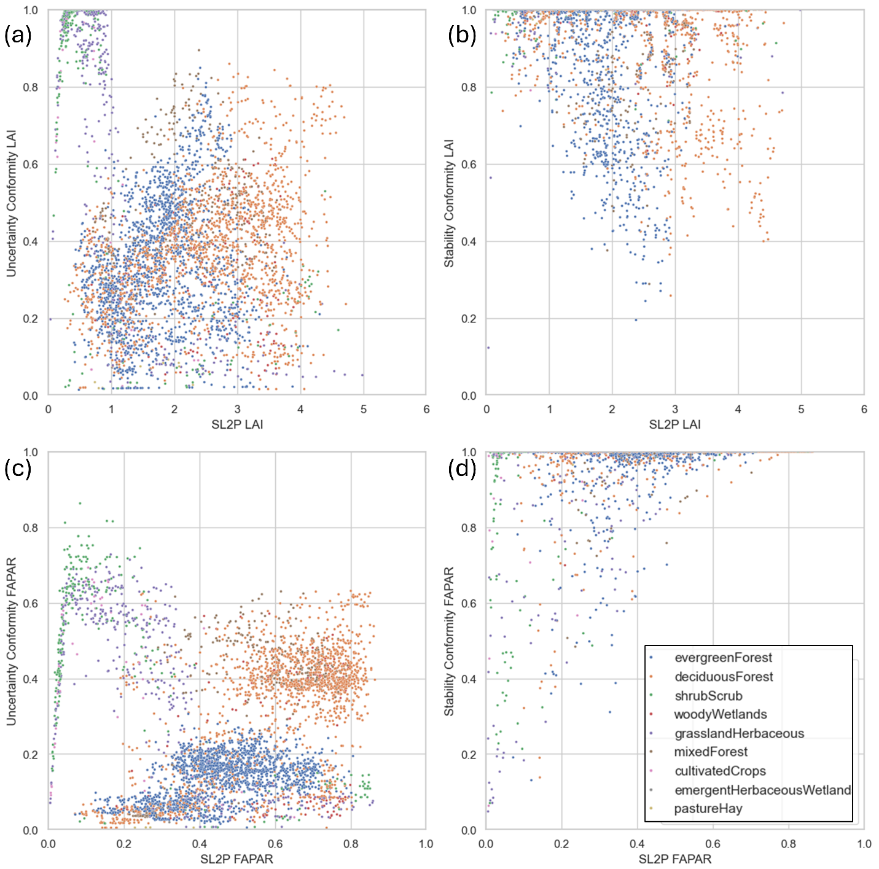
Figure 9. Probability of meeting Uncertainty and Stability Threshold requirements assuming expected value of zero for Uncertainty and Stability but retaining confidence intervals (a,b) LAI and (c,d) FAPAR.

4.6 Algorithm Intercomparison

Intercomparisons of SL2P algorithms was performed by comparing conditional intervals of uncertainty and stability (Figure 10) for SL2P HLS L30 products (sold contours) and SL2P HLS S30 products (dashed contours) rather than individual matchups due to the sensitivity of the latter to measurement errors and due to the fact that L30 and S30 FDRs matchups do not always coincide. Contours corresponding to the conditional expected value of validation statistics (blue), the 67%ile interval (orange) and the extreme 90%ile interval (gray) were compared separately since products may agree for typical cases but disagree for matchups at specific sites or with specific acquisition conditions.

In terms of LAI uncertainty, for 90%ile and 67%ile intervals the S30 and L30 estimates had similar lower limits but the S30 uncertainty upper limits were between 20% to 40% lower than the L30 uncertainty. Additionally, for the 10%ile interval, that includes the expected conditional uncertainty, while S30 and L30 uncertainty was similar for LAI<1.5, for larger LAI estimates the L30 uncertainty rapidly increased to ~0.5 while the S30 uncertainty only gradual increased to ~0.35. These results highlight differences in both typical uncertainty and worst case uncertainty between L30 and S30 LAI estimates. In contrast FAPAR uncertainty contours were generally similar between S30 and L30 products. One exception being that cases of multimodal uncertainty estimates were more frequent for L30 versus S30 suggesting the former may be more susceptible to random effects associated with acquisition conditions such as atmospheric haze or shadows in contrast to slow varying land surface conditions such as canopy structure or optical properties.

S30 and L30 has virtually identical stability for the 10%ile intervals. However, for LAI, S30 had substantially worse stability than L30 products for the 90%ile intervals. This is likely due to the fact that S30 matchups spanned three fewer years than the L30 matchups and subsequently the prediction intervals for some S30 matchups was often large due to the limited number of sampled changes in bias over time. A longer time span of matchups is required to determine if this is the case or if the S30 product is less stable than L30 product for worst case conditions due to sensor differences in input reflectance data products or due to differences in spectral sampling between S30 and L30 algorithms.

Intercomparisons of conformity probability could also have been presented but were not conducted due to the previously documented sensitivity of conformity probability to the confidence intervals of validation statistics. This sensitivity not only masks real differences between product estimates but also results in highly skewed conditional distributions of conformity probability (Figure 8) so that meaningful comparisons of even conditional distributions from different products are not currently possible.

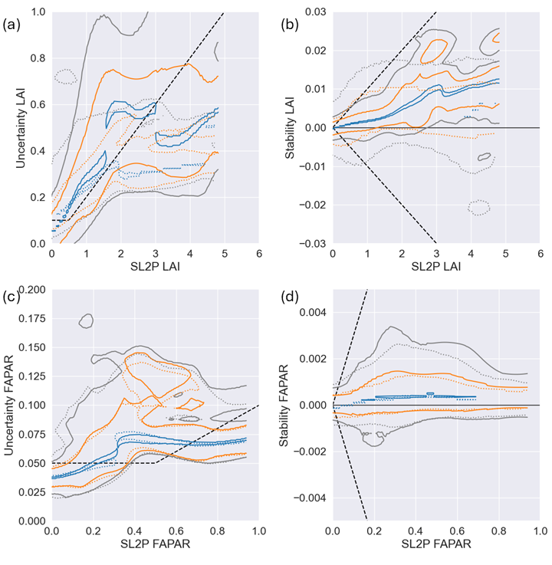
Figure 10. Contour plots of SL2P HLS L30 (solid lines) and SL2P HLS S2 (dotted lines) product estimates for (a) LAI uncertainty, (b) LAI stability, (a) LAI uncertainty, (b) LAI stability versus SL2P estimate. Uncertainty and stability are estimated all FRM measurements and parameters . Blacked dashed lines correspond to modified GCOS threshold requirements. . Contours indicate marginal probability of statistic given FRM for probability mass fractions for 0.1 (blue), 0.67 (orange) and 0.9 (grey).

4.7 Global Validation

CEOS Validation Stage 4 requires ongoing global product validation using FRM. The methodology for estimating global validation statistics is identical to that for estimates over a matchup with the exception of using only global parameters to model inclusion probabilities. The usefulness of this method relies on the extent to which statistics based on global parameters match (or at least are more pessimistic) than those based on all parameters available at a matchup and on the maximum relative inclusion probability for global product measurement conditions compared to the maximum relative inclusion probability observed for matchups.

LAI uncertainty estimates for matchups using inclusion probabilities estimated with global parameters while also holding out matchups at the same site (Uncertainty LAI global or simply global LAI uncertainty) shows a similar level of agreement for the uncertainty previously quantified using all FRM and parameters (Uncertainty LAI FRM or simply FRM LAI uncertainty) for low (<0.25) uncertainty (Figure 11a). For higher levels of uncertainty, the global LAI uncertainty was generally larger than the local FRM estimate by between 10% and 50%. Some exceptions were observed where the local FRM LAI uncertainty was substantially (over 100%) more than the global LAI uncertainty . However, these cases almost always corresponded to very large confidence intervals for the FRM uncertainty estimate so they correspond to biased FRM uncertainty estimates.

Global and FRM FAPAR uncertainty were similar for broadleaf vegetation but global estimates were between 26% and 100% greater than FRM estimates for needle leaf vegetation Figure 11b).. It is likely that this additional uncertainty for global vegetation is due to the lack of woody area index information when modelling global inclusion probabilities as the SL2P algorithm does not include woody area.

In contrast to uncertainty, global estimates of stability agree well with FRM estimates, with differences typically smaller than the confidence intervals of estimates for a given matchup Figure 11c,d).
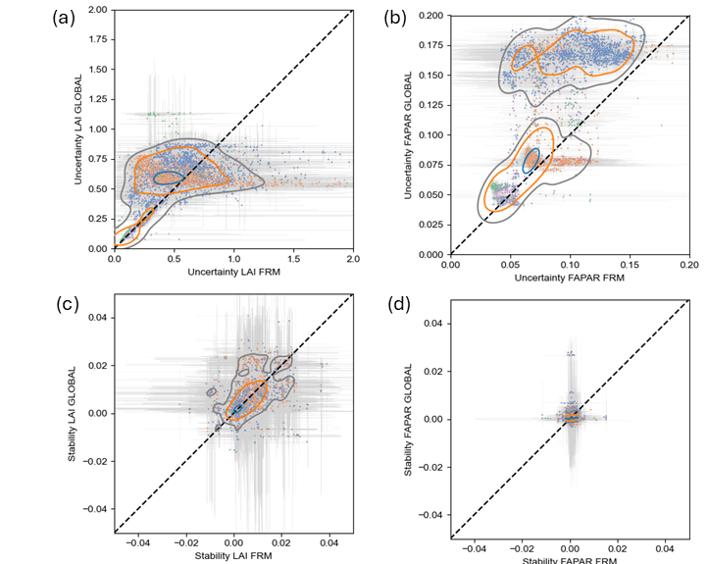
Figure 11. Comparison of Uncertainty and Stability as a function of product measurement using estimates based on all FRM measurements and parameters (FRM) versus FRM measurements at other sites and global parameters (GLOBAL). Contours indicate joint central probability mass fractions for 0.1 (blue), 0.67 (orange) and 0.9 (grey). Whiskers indicate one standard deviation intervals of estimates.

Maximum annual SL2 HLS L30 retrievals, together with associated maximum inclusion probability, uncertainty and stability were estimated for the global 100km grid samples. Monthly or daily values are possible but not shown for brevity. Patterns of both LAI (Figure 12a) and FAPAR (Figure 13a) are plausible considering the SL2P algorithm bias, but their relevance to downstream use cases beyond the scope of this study. Maximum inclusion probabilities for LAI (Figure 12b) and FAPAR (Figure 13b) are generally high in temperate and sub-arctic biomes and low in equatorial regions and south-central Asia.

LAI uncertainty (Figure 12c) are and FAPAR uncertainty (Figure 13c) are generally proportional to the SL2P estimate with the exception of central Africa where they are indicated as relatively large but one should keep in mind this region is likely not represented by matchups. In contrast, stability is generally very good (near 0yr⁻¹) for both LAI (Figure 12d) are and FAPAR (Figure 13d) but there are isolated areas of poor stability in Europe, the central US and the Boreal zone. These areas may correspond to regions with land cover change, resulting in changes in bias over time related to the land surface rather than observing system. This result identifies a weakness with our approach to quantifying stability since it does not distinguish between these sources of bias change over time.
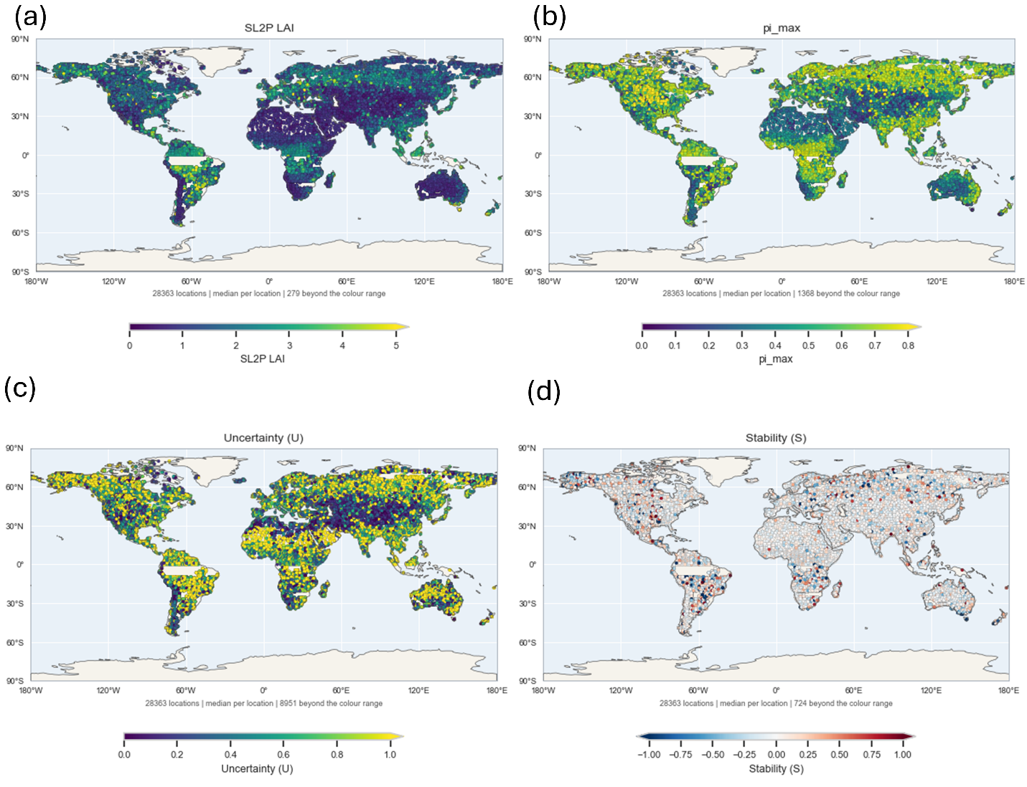
Figure 12. Global 100km grid samples of (a) maximum SL2P HLS L30 LAI and associated (b) inclusion probability, (c ) uncertainty and (d) stability.
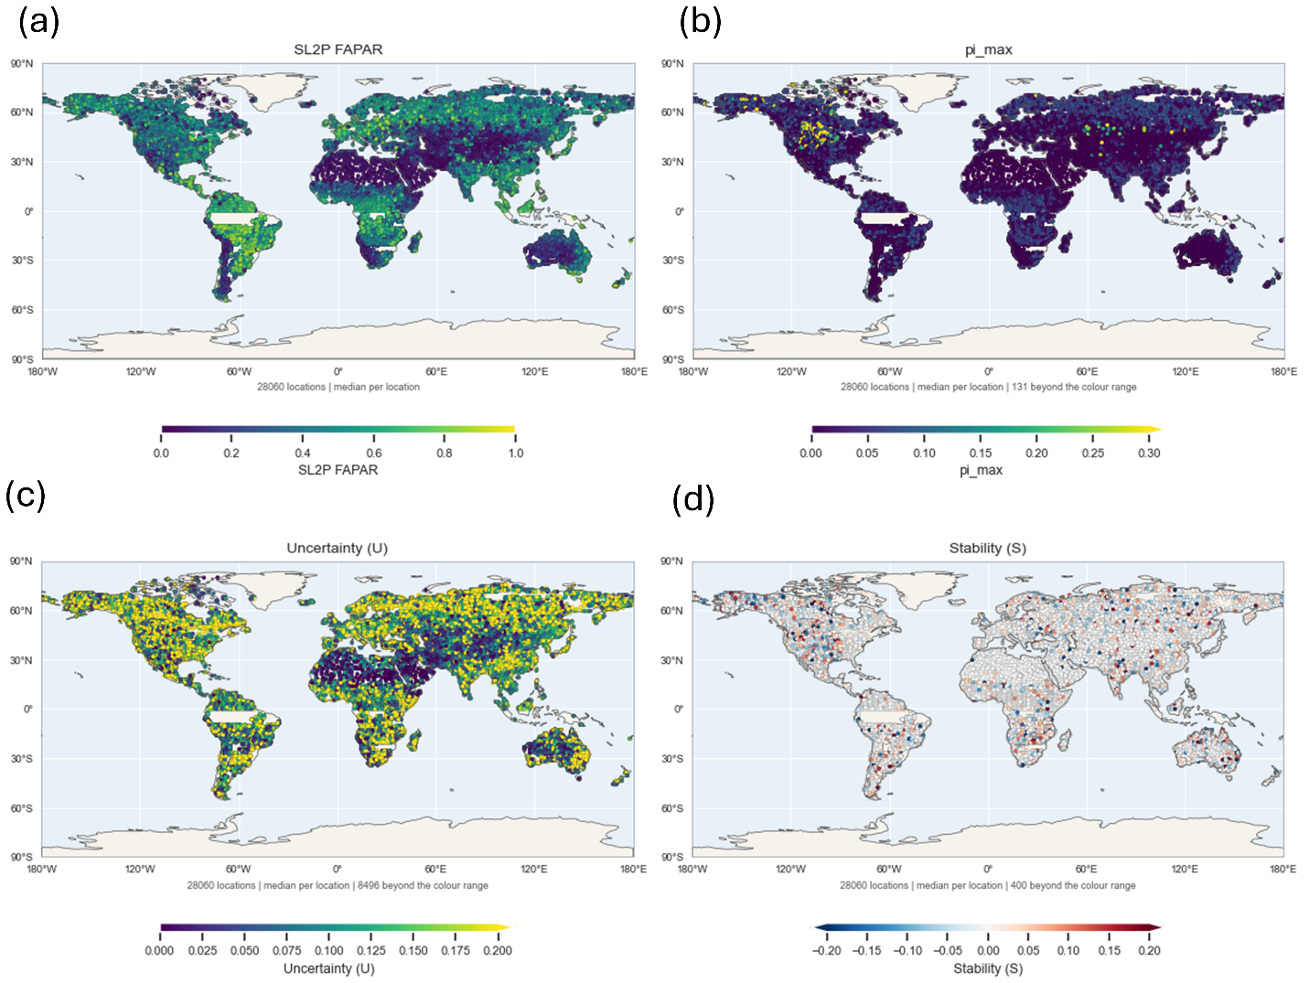
Figure 13. Global 100km grid samples of (a) maximum SL2P HLS L30 FAPAR and associated (b) inclusion probability, (c ) uncertainty and (d) stability.

Discussion

This study departs from virtually all previous LAI/FAPAR validation studies other than Camacho et al., 2024 in that it validates conformity to user requirements rather than simply presenting statistical summaries of residuals. Even the prior CEOS good practice (Fernandes et al., 2014) did not actually assess conformity. This gap between practice and need brings into question the relevance of previous validation studies to the mission requirements of satellite missions or bodies such as GCOS for the thematic quality of LAI/FAPAR products. Three major gaps are addressed by the developed validation method:

- Uncertainty estimation. Most LAI/FAPAR user requirements specify a target for relative standard uncertainty. This is reasonable both because modelling studies suggest measurement errors for LAI, and to some extent FAPAR, are multiplicative (Weiss et al., 2020) and because these translate into relative errors in fluxes and indicators derived from models that consume LAI/FAPAR inputs (GCOS, 2024). But previous studies, including Camacho et al., 2024) do not actually quantified uncertainty using reference measurements since they do not apply bias correction and since the majority of studies report error statistics either for entire ranges of LAI/FAPAR found in the reference database as recommended by Berger et al. (2019) or conditional on the reference measurement as recommended by Fernades et al. (2014).

- Representativeness. Previous studies have not provided an approach to identify the replicates required for quantifying uncertainty or bias using FRM. This is a challenging task for LAI/FAPAR products since there are numerous sources of error that vary in space and time in a manner that cannot be easily controlled. Moreover, sources of error such as the actual LAI/FAPAR, the clumping index, woody area index are not generally available except at in-situ FRM sampling sites. Folling guidance from the Joint Council on Metrology, this problem is addressed here by modelling inclusion probabilities both at FRM and globally using parameters. The models used here are admittedly incomplete as not all error sources are described, even for FRM. However, missing errors components will generally increase the expected value of uncertainty estimates, as seen when comparing FRM versus GLOBAL uncertainty estimates, since replicates will include variability due to different error conditions. At the same time, the confidence intervals of uncertainty estimates will be underestimated if error sources are not included but these are already large for current matchups with FRM. Improved uncertainty estimates would require additional FRM sampling over different conditions that is not available with current datasets.

- Stability. This is only the second study that quantified LAI/FAPAR stability. Djamai et al. (2024) produced an initial estimate of stability for individual ESUs with sufficient temporal sampling by comparing changes in bias between successive years. We extent this approach by using robust regression approaches to quantify ESU stability and then using the inclusion probabilities to estimate stability based on all similar ESUs.

Our study followed QA4EO good practice of propagating uncertainty from product and reference measurements to validation statistics and conformity probabilities. In contrast to most other studies, robust rank order statistics were used to reduce the impact of FRM measurement errors, matchup uncertainty due to temporal and spatial mismatch, and assumptions regarding inclusion probabilities on validation statistics. This approach required detailed but mature statistical theory that may be unfamiliar to the earth observation community but is essential to our method. To this end we have provided open source code to replicate our study so the community can adapt it for future use.

The actual uncertainty and stability of SL2P products are not of primarily importance for this discussion as our study focused on methodology rather than specified products. Suffice it to note that LAI and FAPAR relative standard uncertainty are large and even their expected values exceed the GCOS requirements for the majority of comparisons at FRM sites while stability is generally within GCOS requirements. However, there are two important aspects for our method that are not usually addressed in other validation studies:

- Non-stationary uncertainty. The conditional distribution of uncertainty for a given product measurement varies with the product measurement magnitude in a non-linear and multimodal manner. Our results clearly indicates that population statistics for uncertainty can be misleading for testing user requirements and even approaches such as linear regression fits to conditional uncertainty estimates (e.g. Fernandes et al., 2024) are misleading if the conditional relationship is multimodal and therefore not functional. Our method relies on explicitly estimating and visualizing conditional distributions of uncertainty. While not offering the simplicity of population or regression estimators this approach not only accounts for complex uncertainty patterns but allows for comparisons between products based on different sets of matchups. In preinciple one could add robust functional estimators for modes within observed uncertainty samples as in Fernandes et al. (2024) to provide a concise quantitative model of uncertainty but we suggest that this is premature due to the limited number of matchups.

- Estimation of conformity probability. Estimating conformity requires realistic (or at least pessimistic) estimates of confidence intervals for both the desired validation statistics (uncertainty or stability in our case) and product measurement to test conformity. Previous studies (Widlowski et al., 2016; Camacho et al. 2024) demonstrated the need to include confidence intervals to determine if an uncertainty estimate conforms with a requirement at better than a certain probability level. Here, we generalize this approach by simply reporting the probability of conformity for each estimate of uncertainty or stability. This allows users of product to decide on a per-retrieval basis if the conformity probability is sufficient for their application. Our approach also indicates that limited matchups and large uncertainty of estimated residuals combine to essentially render any conformity test to current GCOS uncertainty requirements uninformative.

It may be that current matchups do not allow for testing conformity of SL2P LAI and FAPAR estimates to stringent GCOS requirements without further control of error conditions. This could be performed for well monitored super sites but would offer limited benefit for global conditions. An alternative may be to develop simulation models for synthetic sites but this would require CEOS and GCOS to permit validation without using FRM. Until that time it may be more useful to simply consider the expected value of uncertainty when evaluating product fitness.

Global estimation of uncertainty and stability are simplified by the fact that, for most cases, the use of global inclusion probabilities results in pessimistic estimates of both statistics. This is expected since the simplified inclusion probabilities, based only on land cover, climate and the product estimate, will include a greater range of error conditions within replicates. Additionally, the maximum inclusion probability provides a useful relative indicator as to whether the estimate uncertainty or stability for a arbitrary retrieval are based on similar FRM sites. Further analysis of the agreement between global and site specific uncertainty and stability as a function of the maximum inclusion probability should be performed but is beyond the scope of this study.

We only presented results for peak global LAI/FAPAR for brevity. Analysis of temporal trends in uncertainty may be informative as to both mission performance and the expected range over time. Stability estimates seem to have low maximum inclusion probabilities in areas with vegetation disturbance (agricultural areas with changing land cover and burnt areas) as these areas are not well represented in the GroundEO FRM. Quantifying stability due to algorithm or sensor inputs versus land cover change is not addressed here but may be facilitated by using land cover change information to partition stability estimates.

While this study provides practical approaches for quantifying the uncertainty and stability of moderate resolution LAI/FAPAR products it used only a single FRM dataset and two very similar similar input satellite data records and mapping algorithms. While there is no reason to suspect that the validation method should apply to other reference and product data one should note that validation using other datasets may result in less consistency in results if matchups are limited (e.g. using products from recently launched sensors or from sensors with limited spatial sampling such as GEDI) or if FRM have systematic errors themselves. It remains for the community to apply these methods to additional datasets and refine them as issues arise.

This study represents a major break from convention in both the use of replicates based on inclusion probabilities and in the use of robust conditional statistics. This shift in good practice may be difficult to encourage in future studies since the authors and editors of many validation studies are happy to simply report population accuracy statistics and bias estimates assuming linear bias as a function of reference measurements. Population statistics without bias correction has limited relevance to current product user requirements and could result in incorrect conclusions when comparing products. Reanalyses of previous studies using our method versus the status quo would be useful to determine if conclusions and recommendations from those studies need revisiting.

Finally, our method is fundamentally limited by the number of replicate matchups for each condition found in product measurements. The future holds promise for daily moderate resolution LAI/FAPAR products with global coverage, barring perhaps clouds but the lack of dense spatial and temporal coverage of FRM will remain a limiting factor for conformity testing. New automated temporal sampling systems would increase the diversity of validated error conditions but would likely not include cases such as disturbance and land use change where remote LAI/FAPAR monitoring is often the only available dataset. Again, a validation platform based on simulated measurements, themselves traceable to FRM, may be a necessary compromise.

Conclusion

LAI and FAPAR are widely used for monitoring and modelling earth system dynamics. User requirements for the thematic quality of satellite derived LAI/FAPAR products have been established by national and intergovernmental groups including GCOS. These requirements include the uncertainty and stability of each product measurement. While previous studies have provided methods to quantify uncertainty and stability the majority have not followed the CEOS requirement to follow QA4EO guidelines that require both the use of fiducal reference measurements and the quantification of the conformity of product measurements with user requirements.

Our study developed a theoretical framework for estimating the uncertainty and stability of arbitrary product measurements through comparisons with fiducial reference measurements. This framework relied on inclusion probabilities to not only estimate statistics based on matchups sharing similar conditions but to apply estimates to global product measurements. Additionally, by also estimating the standard deviation of both uncertainty and stability, our approach was able to quantify the probability a given measurement conformed to a given (in the case GCOS) user requirement.

Application of our methodology to a global sample of 30m resolution LAI and FAPAR time series derived by applying the SL2P algorithm to the Harmonized Landsat and Sentinel 2 showed that for SL2P using Landsat bands, considering the 67.5%ile interval of validation statistics, LAI uncertainty stayed below 1 and FAPAR uncertainty below 0.1 , with both products showing a stability <0.02yr-1. The relationship between uncertainty and product measurements was both non-linear and multi-modals, suggesting statistics stratified by land cover or product measurement levels can be misleading for global validation. SL2P with Sentinel 2 bands resulted in similar stability but improved uncertainty by up to 50% depending on measurement level and land cover.

For both LAI and FAPAR the probability of conformity with GCOS uncertainty requirements was low (<0.5) and stability high (>0.5) . The low conformity for uncertainty was partly due to wide confidence intervals of individual uncertainty estimates due to matchup heterogeneity, and uncertainty of FRM and product measurements. This suggests that current the both the number and accuracy of current FRM will need to be increased to enable reliable validation of GCOS requirements. validation statistics limited to matchups w

Acknowledgements

References

Berger, K., Atzberger, C., Hank, T., & Mauser, W. (2012). Derivation of biophysical variables from Earth observation data: Validation and statistical measures. Journal of Applied Remote Sensing, 6, 063557-1. https://doi.org/10.1117/1.JRS.6.063557

Brown, L. A., Camacho, F., García-Santos, V., Origo, N., Fuster, B., Morris, H., Pastor-Guzman, J., Sánchez-Zapero, J., Morrone, R., Ryder, J., et al. (2021a). Fiducial reference measurements for vegetation bio-geophysical variables: An end-to-end uncertainty evaluation framework. Remote Sensing, 13(16), 3194. https://doi.org/10.3390/rs13163194

Brown, L., Fernandes, R., Djamai, N., Meier, C., Gobron, N., Morris, H., Canisius, F., Bai, G., Lerebourg, C., Lanconelli, C., Clerici, M., & Dash, J. (2021b). Validation of baseline and modified Sentinel-2 Level 2 Prototype Processor leaf area index retrievals over the United States. ISPRS Journal of Photogrammetry and Remote Sensing, 175, 71–87. https://doi.org/10.1016/j.isprsjprs.2021.02.020

Brown, L. A., Fernandes, R., Verrelst, J., Morris, H., Djamai, N., Reyez-Muñoz, P., Kovács, D., & Meier, C. (2025). GROUNDED EO: Data-driven Sentinel-2 LAI and FAPAR retrieval using Gaussian processes trained with extensive fiducial reference measurements. Remote Sensing of Environment. https://doi.org/10.1016/j.rse.2025.114797

Brown, L. A., Meier, C., Morris, H., Pastor-Guzman, J., Bai, G., Lerebourg, C., Gobron, N., Lanconelli, C., Clerici, M., & Dash, J. (2020). Evaluation of global leaf area index and fraction of absorbed photosynthetically active radiation products over North America using Copernicus Ground Based Observations for Validation data. Remote Sensing of Environment, 247, 111935.

Buchhorn, M., Lesiv, M., Tsendbazar, N.-E., Herold, M., Bertels, L., & Smets, B. (2020). Copernicus Global Land Cover Layers—Collection 2. Remote Sensing, 12(6), 1044. https://doi.org/10.3390/rs12061044

Camacho, F., Martínez-Sánchez, E., Brown, L. A., Morris, H., Morrone, R., Williams, O., Dash, J., Origo, N., Sánchez-Zapero, J., & Boccia, V. (2024). Validation and conformity testing of Sentinel-3 Green Instantaneous FAPAR and canopy chlorophyll content products. Remote Sensing, 16(15), 2698. https://doi.org/10.3390/rs16152698

Campos-Taberner, M., García-Haro, F. J., Camps-Valls, G., Grau-Muedra, G., Nutini, F., Busetto, L., Katsantonis, D., Stavrakoudis, D., Minakou, C., Gatti, L., Barbieri, M., Holecz, F., Stroppiana, D., & Boschetti, M. (2017). Exploitation of SAR and optical Sentinel data to detect rice crop and estimate seasonal dynamics of leaf area index. Remote Sensing, 9(3), 248. https://doi.org/10.3390/rs9030248
CEOS. (2018). Space agency response to GCOS implementation plan (Version 2.2.1). Joint CEOS/CGMS Working Group on Climate (WGClimate).

Chabrillat, S., Guanter, L., Kaufmann, H., Foerster, S., Beamish, A., Brosinsky, A., Wulf, H., Asadzadeh, S., Bochow, M., Bohn, N., Boesche, N., Bracher, A., Brell, M., Buddenbaum, H., Cerra, D., Fischer, S., Hank, T., Heiden, U., Heim, B., Heldens, W., Hill, J., Hollstein, A., Hostert, P., Krasemann, H., LaPorta, L., Leitão, P. J., van der Linden, S., Mauser, W., Milewski, R., Mottus, M., Okujeni, A., Oppelt, N., Pinnel, N., Roessner, S., Röttgers, R., Schneiderhan, T., Schickling, A., Soppa, M., Staenz, K., & Segl, K. (2022). EnMAP science plan (EnMAP Technical Report). GFZ Data Services. https://doi.org/10.48440/enmap.2022.001

Commission for Environmental Cooperation. (2023). 2020 land cover of North America at 30 meters. North American Land Change Monitoring System. https://developers.google.com/earth-engine/datasets/catalog/USGS_NLCD_RELEASES_2020_REL_NALCMS

Defourny, P., Bontemps, S., Bellemans, N., Cara, C., Dedieu, G., Guzzonato, E., Hagolle, O., Inglada, J., Nicola, L., Rabaute, T., Savinaud, M., Udroiu, C., Valero, S., Bégué, A., Dejoux, J.-F., El Harti, A., Ezzahar, J., Kussul, N., Labbassi, K., . . . Koetz, B. (2019). Near real-time agriculture monitoring at national scale at parcel resolution: Performance assessment of the Sen2-Agri automated system in various cropping systems around the world. Remote Sensing of Environment, 221, 551–568. https://doi.org/10.1016/j.rse.2018.11.007

Djamai, N., Fernandes, R. A., Sun, L., Canisius, F., & Hong, G. (2024). Python version of Simplified Level 2 Prototype Processor for retrieving canopy biophysical variables from Sentinel-2 multispectral data (Geomatics Canada Open File 81). https://doi.org/10.4095/p8stuehwyc

Dodge, Y. (2003). The Oxford Dictionary of Statistical Terms. OUP. ISBN 0-19-850994-4.
Dowell, M., Lecomte, P., Husband, R.,. Schulz, J., Mohr, T.. Tahara, Y., Eckman, R.,. Lindstrom, E., Wooldridge, C., Hilding, S., Bates, J., Ryan, B., Lafeuille, J., and Bojinski, S. (2013): Strategy Towards an Architecture for Climate Monitoring from Space. Pp. 39. http://ceos.org/document_management/Working_Groups/WGClimate/Documents/ARCH_strategy-climate-architecture-space.pdf

Dubayah, R., Blair, J. B., Goetz, S., Fatoyinbo, L., Hansen, M., Healey, S., Hofton, M., Hurtt, G., Kellner, J., Luthcke, S., Armston, J., Tang, H., Duncanson, L., Hancock, S., Jantz, P., Marselis, S., Patterson, P. L., Qi, W., & Silva, C. (2020). The Global Ecosystem Dynamics Investigation: High-resolution laser ranging of the Earth’s forests and topography. Science of Remote Sensing, 1, 100002. https://doi.org/10.1016/j.srs.2020.100002

Fang, H., Baret, F., Plummer, S., & Schaepman-Strub, G. (2019). An overview of global leaf area index (LAI): Methods, products, validation, and applications. Reviews of Geophysics, 57, 739–799. https://doi.org/10.1029/2018RG000608

Food and Agriculture Organization of the United Nations. (2025). Global forest resources assessment 2025. https://doi.org/10.4060/cd6709en

Fernandes, R., Brown, L., Canisius, F., Dash, J., He, L., Hong, G., Huang, L., Le, N. Q., MacDougall, C., Meier, C., Darko, P. O., Shah, H., Spafford, L., & Sun, L. (2023). Validation of simplified Level 2 Prototype Processor Sentinel-2 fraction of canopy cover, fraction of absorbed photosynthetically active radiation, and leaf area index products over North American forests. Remote Sensing of Environment, 293, 113600. https://doi.org/10.1016/j.rse.2023.113600

Fernandes, R., Djamai, N., Harvey, K., Hong, G., MacDougall, C., Shah, H., & Sun, L. (2024). Evidence of a bias-variance trade-off when correcting for bias in Sentinel-2 forest LAI retrievals using radiative transfer models. Remote Sensing of Environment, 305, 114060. https://doi.org/10.1016/j.rse.2024.114060

Fernandes, R., Plummer, S., Nightingale, J., Baret, F., Camacho, F., Fang, H., Garrigues, S., Gobron, N., Lang, M., Lacaze, R., Leblanc, S., Meroni, M., Martinez, B., Nilson, T., Pinty, B., Pisek, J., Sonnentag, O., Verger, A., Welles, J., Weiss, M., Widlowski, J.-L., Schaepman-Strub, G., Roman, M., & Nickeson, J. (2014). Global leaf area index product validation good practices. In R. Fernandes, S. Plummer, & J. Nightingale (Eds.), Best practice for satellite-derived land product validation. Land Product Validation Subgroup, Committee on Earth Observation Satellites Working Group on Calibration and Validation. https://doi.org/10.5067/DOC/CEOSWGCV/LPV/LAI.002

Fernandes, R., Tang, H., & Brown, L. (2024a). Proposed definition of leaf area index by the Committee on Earth Observation Satellites (Geomatics Canada Open File 86). https://doi.org/10.4095/p9fzmg1djq

Fernandes, R., Tang, H., & Brown, L. (2024b). Proposed definition of fraction of absorbed photosynthetically active radiation by the Committee on Earth Observation Satellites (Geomatics Canada Open File 85, Version 1.0). https://doi.org/10.4095/p3gy844zex

Fuster, B., Sánchez-Zapero, J., Camacho, F., García-Santos, V., Verger, A., Lacaze, R., Weiss, M., Baret, F., & Smets, B. (2020). Quality assessment of PROBA-V LAI, fAPAR and fCOVER Collection 300 m products of Copernicus Global Land Service. Remote Sensing, 12(6), 1017. https://doi.org/10.3390/rs12061017

Gascon, F., Bouzinac, C., Thépaut, O., Jung, M., Francesconi, B., Louis, J., Lonjou, V., Lafrance, B., Massera, S., Gaudel-Vacaresse, A., Languille, F., Alhammoud, B., Viallefont, F., Pflug, B., Bieniarz, J., Clerc, S., Pessiot, L., Trémas, T., Cadau, E., . Fernandez, V. (2017). Copernicus Sentinel-2A calibration and products validation status. Remote Sensing, 9(6), 584. https://doi.org/10.3390/rs9060584

Gaudel, A., Languille, F., Delvit, J., Michel, J., Cournet, M., & Poulain, V. (2017). Sentinel-2 global reference image validation and application to multitemporal performances and high latitude digital surface model. The International Archives of the Photogrammetry, Remote Sensing and Spatial Information Sciences, XLII-1/W1, 447–454. https://doi.org/10.5194/isprs-archives-XLII-1-W1-447-2017

GEOGLAM. (2022). Full EAV table | AgVariables. https://agvariables.org/

Goryl, P., Fox, N., Donlon, C., & Castracane, P. (2023). Fiducial Reference Measurements (FRMs): What Are They? Remote Sensing, 15(20), 5017. https://doi.org/10.3390/rs15205017

Joint Committee for Guides in Metrology. (2012). The role of measurement uncertainty in conformity assessment (JCGM 106:2012). https://doi.org/10.59161/JCGM106-2012

Joint Committee for Guides in Metrology. (2021). International vocabulary of metrology—Basic and general concepts and associated terms (4th ed.; JCGM-WG2-CD-01).

Ju, J., Zhou, Q., Freitag, B., Roy, D. P., Zhang, H. K., Sridhar, M., Mandel, J., Arab, S., Schmidt, G., Crawford, C. J., Gascon, F., Strobl, P. A., Masek, J. G., & Neigh, C. S. R. (2025). The Harmonized Landsat and Sentinel-2 Version 2.0 surface reflectance dataset. Remote Sensing of Environment, 324, 114723. https://doi.org/10.1016/j.rse.2025.114723

Lanconelli, C., Cappucci, F., Adams, J., & Gobron, N. (2024). Evaluation of in situ FAPAR measurement protocols using 3D radiative transfer simulations. Remote Sensing, 16(23), 4552. https://doi.org/10.3390/rs16234552

Malenovský, Z., Rott, H., Cihlar, J., Schaepman, M. E., García-Santos, G., Fernandes, R., & Berger, M. (2012). Sentinels for science: Potential of Sentinel-1, -2, and -3 missions for scientific observations of ocean, cryosphere, and land. Remote Sensing of Environment, 120, 91–101. https://doi.org/10.1016/j.rse.2011.09.026

Monteith, J. L. (1972). Solar radiation and productivity in tropical ecosystems. Journal of Applied Ecology, 9(3), 747–766. https://doi.org/10.2307/2401901

Muñoz-Sabater, J., Dutra, E., Agustí-Panareda, A., Albergel, C., Arduini, G., Balsamo, G., Boussetta, S., Choulga, M., Harrigan, S., Hersbach, H., Martens, B., Miralles, D. G., Piles, M., Rodríguez-Fernández, N. J., Zsoter, E., Buontempo, C., & Thépaut, J.-N. (2021). ERA5-Land: A state-of-the-art global reanalysis dataset for land applications. Earth System Science Data, 13, 4349–4383. https://doi.org/10.5194/essd-13-4349-2021

Navarro, L. M., Fernández, N., Guerra, C., Guralnick, R., Kissling, W. D., Londoño, M. C., et al. (2017). Monitoring biodiversity change through effective global coordination. Current Opinion in Environmental Sustainability, 29, 158–169.

Stavros, E. N., Chrone, J., Cawse-Nicholson, K., Freeman, A., Glenn, N. F., Guild, L., Kokaly, R., Lee, C., Luvall, J., Pavlick, R., Poulter, B., Schollaert Uz, S., Serbin, S., Thompson, D. R., Townsend, P. A., Turpie, K., Yuen, K., Thome, K., Wang, W., Zareh, S. K., Nastal, J., Bearden, D., Miller, C. E., & Schimel, D. (2023). Designing an observing system to study the surface biology and geology (SBG) of the Earth in the 2020s. Journal of Geophysical Research: Biogeosciences, 128(1), e2021JG006471. https://doi.org/10.1029/2021JG006471

Stehman, S. V., & Czaplewski, R. L. (1998). Design and analysis for thematic map accuracy assessment: Fundamental principles. Remote Sensing of Environment, 64, 331–344. https://doi.org/10.1016/S0034-4257(98)00010-8

Tyukavina, A., Stehman, S. V., Foody, G. M., Bontemps, S., See, L., Olofsson, P., Tsendbazar, N., Radoux, J., Komarova, A., Serre, B., Song, X., d’Andrimont, R., Koren, G., Potapov, P., Bullock, E. L., Campbell, P., de Bruin, S., Defourny, P., Friedl, M. A., Fritz, S., et al. (2025). Land cover and change map accuracy assessment and area estimation good practices protocol (Version 1.0). CEOS Working Group on Calibration and Validation. https://doi.org/10.5067/DOC/CEOSWGCV/LPV/LC.001

United Nations, Department of Economic and Social Affairs, Statistics Division. (2022). Guidelines on biophysical modelling for ecosystem accounting. https://seea.un.org/ecosystem-accounting/biophysical-modelling

Verger, A., Weiss, M., & Baret, F. (2025). GEOV2-AVHRR: Continuous and consistent time series of global leaf area index and fraction absorbed PAR from 1981 to 2022. Remote Sensing of Environment, 331, 115029. https://doi.org/10.1016/j.rse.2025.115029

Watson, D. J. (1947). Comparative physiological studies in the growth of field crops. I. Variation in net assimilation rate and leaf area between species and varieties, and within and between years. Annals of Botany, 11. https://doi.org/10.1093/oxfordjournals.aob.a083148

Weiss, M., Baret, F., & Jay, S. (2020). S2ToolBox Level 2 products: LAI, FAPAR, FCOVER (Version 2.0). https://step.esa.int/docs/extra/ATBD_S2ToolBox_L2B_V2.0.pdf

Widlowski, J.-L. (2015). Conformity testing of satellite-derived quantitative surface variables. Environmental Science & Policy,51, https://doi.org/10.1016/j.envsci.2015.03.018

World Meteorological Organization. (2022). GCOS implementation plan 2022: The global observing system for climate (GCOS-245, GOOS-269, WMO-No. 1299). https://gcos.wmo.int/en/gcos-implementation-plan-2022

World Meteorological Organization. (2025). The 2022 GCOS ECVs requirements: 2022 edition—Updated in 2025 (GCOS-245). https://library.wmo.int/idurl/4/58111

Zanaga, D., Van De Kerchove, R., De Keersmaecker, W., Souverijns, N., Brockmann, C., Quast, R., Wevers, J., Grosu, A., Paccini, A., Vergnaud, S., Cartus, O., Santoro, M., Fritz, S., Georgieva, I., Lesiv, M., Carter, S., Herold, M., Li, L., Tsendbazar, N.-E., Ramoino, F., & Arino, O. (2021). ESA WorldCover 10 m 2020 v100. https://doi.org/10.5281/zenodo.5571936

Supplementary Material S1 – Glossary

Term | Definition | Reference
accuracy | the closeness of agreement between a measurement result and a reference value of a measurand | JGCM, 2021
analysis | the procedures used to estimate validation statistics from observed differences at matchups, accounting for their associated uncertainties, and to report these estimates so that users can determine whether products meet requirements at a stated level of confidence | SC, 1998
ARIDITY | Ratio of annual potential evapotranspiration to annual precipitation | This study
bias | an estimate of systematic error | JGCM, 2021
breakthrough | performance sufficient for specific applications | WMO, 2025
conditions | measurand and associated influence quantities associated with a measurement | JGCM, 2021
Conformance probability | the probability that a product, item, or process fulfills a specified requirement | JCGM, 2012
conventional value | a value established by agreement and assumed to represent the true value of the measurand | JGCM, 2021
coverage interval | an interval containing the validated quantity (e.g., accuracy) with a stated probability based on the information available | JGCM, 2021
definitional uncertainty | uncertainty arising from the finite specificity of a measurand definition | JGCM, 2021
elementary sampling units | spatiotemporal intervals associated with a reference measurement | This study
error | the measured value minus a reference value | JGCM, 2021
fiducial reference measurement | independent, fully characterised, and traceable sub-orbital measurement that follows the guidelines outlined by the GEO/CEOS Quality Assurance framework for Earth Observation (QA4EO) and has value for space-based observations. | QA4EO, http://qa4eo.org/
Fundamental data records | A Fundamental Climate Data Record (FCDR) is a well-characterised, long-term data record, usually involving a series of instruments, with potentially changing measurement approaches, but with overlaps and calibrations sufficient to allow the generation of products that are accurate and stable, in both space and time, to support climate applications. | Dowell et al., 2013.
FROST | Total number of days in a year with a daily minimum soil temperature (0–7 cm depth) greater than 0°C | This study
GDD | Total annual degree days above a base temperature of 10°C | WMO, 2011
goal | performance that meets all foreseeable user needs | WMO, 2025
inclusion probability | the probability that a specific unit or member of a finite population will be selected into a sample during a single sampling process | Dodge, 2003.
influence quantities | a quantity that does not affect the quantity being measured but that affects the measurement result | JGCM, 2021
Intercomparison | Results based on comparisons the nature of the products being compared is similar and of a similar uncertainty | Goryl et al,, 2023
matchups | Two or more measurements of the same measureand associated with a spatiotemporal interval | This study
measurand | Particular quantity subject to measurement | JGCM, 2021
measurement | A process of experimentally obtaining one or more quantity values that can reasonably be attributed to a quantity | JGCM, 2008
minimum mapping unit | Smallest spatiotemporal interval of a measurement satisfying a user requirement | JGCM, 2021
parameters | Characteristics associated with $\hat{y}$ other than $\hat{y}$ itself used to quantify influence quantities | JGCM, 2021
product measurement | Measurements provided in a product with associated metadata such as mapping units | This study
relative standard accuracy | Standard accuracy divided by the measured value | JGCM, 2021
relative standard uncertainty | Standard accuracy divided by the measured value | JGCM, 2021
repeatable | Condition where residuals share influence quantities that “typically includes measurement procedure, measuring system, measuring system operator, operating conditions, and measurement location held fixed while performing two or more measurements over a period of time … as short as necessary in order to avoid the occurrence of changes in the set of conditions” | JGCM, 2021
representativeness | the maximum inclusion probability | This study
residuals | differences between a product measurement and reference values | JGCM, 2021
response design | all the steps that lead to a decision regarding the agreement between individual RM and product measurements | SC, 1998
sampling design | protocol by which the reference sample units are selected | SC, 1998
Stability | The change in bias, “an estimate of systematic error”, per decade; | WMO, 2025
Standard Uncertainty | Standard deviation of attributed values with respect to a reference value | JGCM, 2021
threshold | minimum usability requirements | WMO, 2025
tolerance limits | intervals of limiting values that separate intervals of permissible values of the measurand from intervals of non-permissible values | JGCM, 2021
Type A validation | where conformity is tested using thematic quality statistics derived from on comparisons of product measurements with fiducial reference measurements | JGCM, 2021
Type B validation | The evaluation of a component of measurement uncertainty determined by means other than a Type A evaluation | JGCM, 2021
Uncertainty | A parameter characterizing the dispersion of values attributed to a measurand after bias correction | JGCM, 2021
Validation | verification, where the specified requirements are adequate for an intended use | JGCM, 2021

Supplementary Material S2 – List of Symbols

Table S2. List of symbols.
Symbol | Definition
$$\hat{y}$$ | product measurement
$$\tilde{y}$$ | fiducial reference measurement
$$y$$ | measureand
$$\underline{x}$$ | parameters
$$π_{i,j}$$ | Inclusion probability of ith sample in sampling distribution of jth sample
$${\hat{π}}_{i,j}$$ | Inclusion probability estimate for parameters without in-situ data
$$π_{min}$$ | minimum inclusion probability
$$\left(\left\{\tilde{ y}\right\},\left\{\hat{y}\right\}\right)$$ | paired set of product and fiducial reference measturements corresponding to a matchup
$$d$$ | date day
$${\tilde{ y}}_{d}$$ | expected value of $\tilde{y}$ for day d
$${\tilde{ s}}_{d}$$ | standard error of ${\tilde{ y}}_{d}$ due to FRM uncertainty
$${\tilde{w}}_{i}$$ | estimated weight for sample I
$${\tilde{ σ}}_{i}$$ | uncertainty of FRM i
$${\hat{r}}_{i,d}$$ | residual between product measurement and FRM for day d at matchup i
$${\hat{σ}}_{r}^{}$$ | Uncertainty of residual r
$${\hat{σ}}_{i}^{}$$ | Prior estimate of product measurement uncertainty
$$r_{d}$$ | residual between product measurement and FRM for day d
$${\hat{n}}_{}$$ | Number of degees of freedom of a statistic
$${\hat{s}}_{{\hat{r}}_{d}}^{}$$ | Standard error in residual for day d due to finite sampling
$${\hat{σ}}_{{\hat{r}}_{d}}^{}$$ | Estimated uncertainty of residual on day d
$${\hat{e}}_{T}$$ | residual between product measurement and FRM for interval T
$$T$$ | Temporal interval of a matchup
$${\overset{ˆ}{s}}_{T}$$ | Standard error of residual for interval T due to temporal variability in conditions
$${\hat{σ}}_{{\hat{e}}_{T}}$$ | Confidence interval of residual for interval T
$${\hat{b}}_{i}$$ | Bias for matchup i
$$σ_{{\hat{b}}_{i}}$$ | One standard deviatuion confidence interval of ${\hat{b}}_{i}$
$${\hat{s}}_{{\hat{b}}_{i}}$$ | Standard error of weighted median ${\hat{b}}_{i}$
$${\hat{u}}_{i}$$ | Standard uncertainty of ${\hat{y}}_{i}$
$$σ_{{\hat{u}}_{i}}$$ | One standard deviation confidence interval of ${\hat{u}}_{i}$
$${\hat{s}}_{{\check{y}}_{i}}^{}$$ | Standard error of reference measurement
$${\hat{δ}}_{{\hat{u}}_{i}}$$ | Estimate of error in estimation of uncertainty due to use of reduced set of parameters for estimating inclusion probability
$${\hat{δ}}_{{\hat{b}}_{i}}$$ | Estimate of error in estimation of biasdue to use of reduced set of parameters for estimating inclusion probability
$${\hat{s}}_{{\hat{u}}_{i}}$$ | Standard error of weighted median estimate ${\hat{u}}_{i}$
$${\hat{u}}_{r,i}$$ | Relative standard uncertainty of ${\hat{y}}_{i}$
$${\hat{σ}}_{{\hat{u}}_{r,i}}$$ | Confidence interval of ${\hat{u}}_{r,i}$
$$Y$$ | year
$${\hat{S}}_{k,l}$$ | Relative slope between year k and year l
$$\hat{S}$$ | Estimated stability
$${\hat{σ}}_{k,l}$$ | Confidence interval of estimate of ${\hat{S}}_{k,l}$

Supplementary Material S3 – Comparison of Site Specific Quality Statistics as a function of heterogeneity.

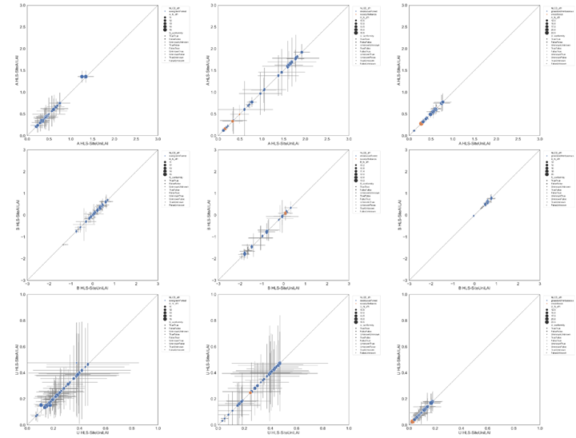
Figure S3.1 Comparison of LAI quality statistics for site specific experiments using all FRM (x-axis) and only homogenous FRM (y-axis). Whiskers correspond to one standard deviation confidence intervals. Colors indicate land cover class. Shape indicates conformity to GCOS requirements for the all FRM experiment. Stability not presented due to lack of matchups with effective degrees of freedom >=10.

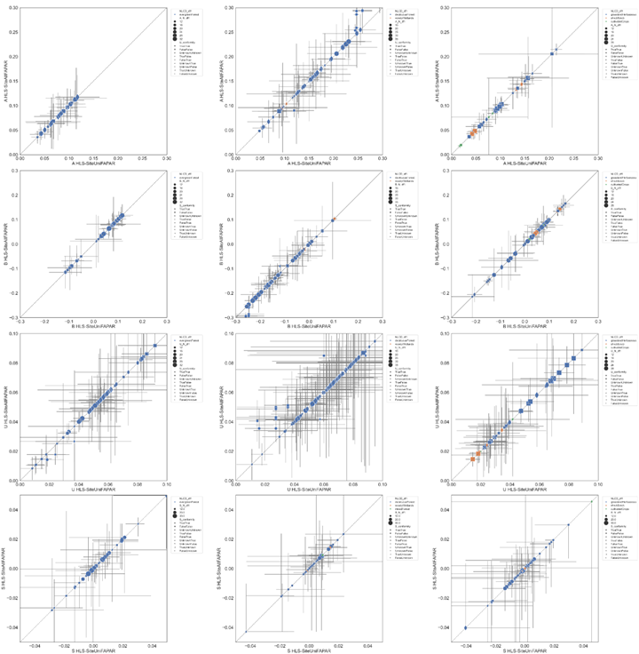
Figure S3.2 Comparison of FAPAR quality statistics for site specific experiments using all FRM (x-axis) and only homogenous FRM (y-axis). Whiskers correspond to one standard deviation confidence intervals. Colors indicate land cover class. Shape indicates conformity to GCOS requirements for the all FRM experiment.

